Microsoft AppSource

*Publishing Guide for Dynamics CRM Solutions*

Customer Led Trials

Table of Contents

Introduction 3

Dev Center Account Setup 3

CRM Solution Preparation 3

CRM AppSource Package Preparation 4

Create a CRM Package 4

Create a CRM AppSource Package 5

Store your CRM AppSource Package to Azure storage and generate a URL with SAS key 6

Setup your application in the Publishing Portal 11

Sign in to the Publishing Center 11

Add an application and enter company/publisher information 11

Enter the information in the CRM PACKAGE section 14

Offer Identifier 14

Application Info 14

CRM Package 14

CRM Package Availability 15

Marketplace Listing Details 15

Products that your app works with 22

Search Keywords 22

Demo videos of your app 22

Documents related to your app 22

Logos and images for your app 23

Lead Management 23

Enter the information in the PLANS section 24

Enter the information in the MARKETING section 25

DETAILS 26

LINKS 29

SAMPLE IMAGES 30

PLANS 30

LEGAL 31

Enter the information in the SUPPORT section 33

Enter the information in the CATEGORIES section 34

Push to staging in the PUBLISH section 35

Appendix A – Lead Management Setup 37

Salesforce 37

Dynamics 39

CSV file that will be stored in a Blob 44

Marketo 47

Azure Table 51

Appendix B – Marketing Metadata Guidelines 54

# Introduction

Thank you for your interest in publishing your CRM solution to AppSource. Microsoft is excited to work with our dedicated ISVs to provide the premier place for customers, resellers, and implementation partners to find and try business solutions and make the most of their investments. This guide will walk you through the steps to get your solution published.

# Dev Center Account Setup

To start, your company will need a developer account. Please follow the instructions below:

<https://azure.microsoft.com/en-us/documentation/articles/marketplace-publishing-accounts-creation-registration/>

If you will have multiple colleagues working on the app, don’t forget to follow to scroll to the bottom and follow the “Steps to add a co-admin in the Publishing portal.”

# CRM Solution Preparation

CRM solutions give you a framework for packaging, installing, and uninstalling components that provide specific business functionality. Solutions are used by ISVs and other Microsoft Dynamics CRM solution providers to distribute extensions they create.

As a CRM ISV, you most likely already have created a managed solution and have a solution.zip file. In your solution, please make sure the “Display Name” and “Description” fields reflect what you want customers to see. These are displayed in the CRM Online Administration Center.

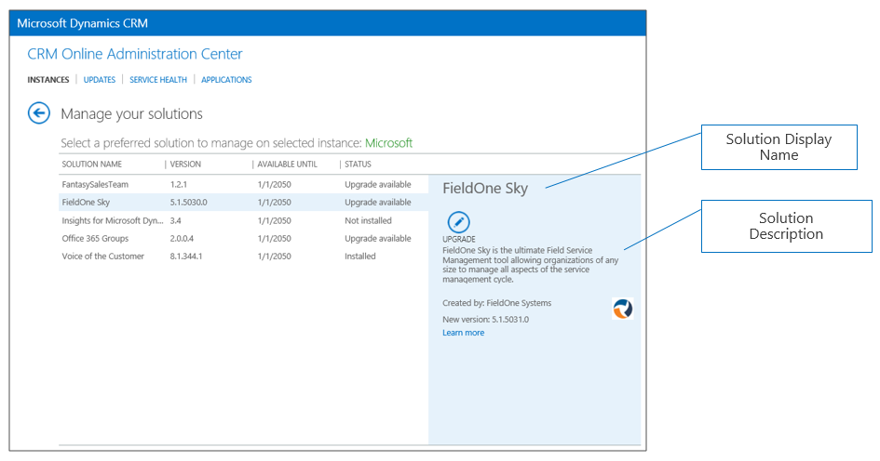

*Note: In the package example that follows we will assume the solution name is “SampleSolution.zip.”*

If you’re a new ISV, you can get more details on creating a solution here: <https://msdn.microsoft.com/en-us/library/gg334530.aspx>

If your solution requires supporting data:

* Create the sample data in your test environment
* Use the Configuration Migration Tool to create a Schema with comparison rules for your data.
* Save your configuration schema with your project files. You will need this later if you update your configuration data.
* Export your configuration data. Be sure to give the export file a name that is meaningful to your export.

# CRM AppSource Package Preparation

In addition to a solution.zip file, you’ll need a CRM AppSource Package. This is a .zip file that includes all the assets needed to automate the process of deploying your solution into the customers’ CRM environment. The steps below will help you create your CRM Package and CRM AppSource Package.

## Create a CRM Package

The CRM Package is one part of the CRM AppSource Package.

To create a CRM Package, use the following instructions: <https://msdn.microsoft.com/en-us/library/dn688182.aspx>. When complete, your package will consist of the assets below:

1. Package folder: contains all solutions, configuration data, flat files, and the contents for your package. *Note: In the example that follows we will assume the package folder is called “PkgFolder.”*
2. PackageName.dll: The assembly contains the custom code for your package. *Note: In the example that follows we will assume this file is called “MicrosoftSample.dll.”*

Now, you need to create a file called “[Content_Types].xml.” This fill will list all of the assets extensions that are part of your package. Here is example code for the file.

<?xml version="1.0" encoding="utf-8"?>   
<Types xmlns="http://schemas.openxmlformats.org/package/2006/content-types">   
<Default Extension="xml" ContentType="application/octet-stream" />   
<Default Extension="xaml" ContentType="application/octet-stream" />   
<Default Extension="dll" ContentType="application/octet-stream" />   
<Default Extension="zip" ContentType="application/octet-stream" />   
<Default Extension="jpb" ContentType="application/octet-stream" />   
<Default Extension="gif" ContentType="application/octet-stream" />   
<Default Extension="png" ContentType="application/octet-stream" />   
<Default Extension="htm" ContentType="application/octet-stream" />   
<Default Extension="html" ContentType="application/octet-stream" />   
<Default Extension="db" ContentType="application/octet-stream" />   
<Default Extension="css" ContentType="application/octet-stream" />  
</Types>

The final step is to zip the following into one file. Please call it **package.zip**. It will contain

1. PkgFolder (including everything inside the folder)
2. PackageName.dll
3. [Content_Types].xml

## Create a CRM AppSource Package

The CRM AppSource Package requires a few additional files.

1. Logo32x32.jpg (32x32 resolution)
2. TermsOfUse.html (HTML formatted file)
3. [Content_Types].xml (same as above)
4. input.xml

Here is example code for input.xml. See definitions in the below table.

<PvsPackageData>   
 <ProviderName>Microsoft</ProviderName>   
 <PackageFile>package.zip</PackageFile>   
 <SolutionAnchorName>SampleSolution.zip</SolutionAnchorName>   
 <StartDate>01/01/2016</StartDate>   
 <EndDate>01/01/2021</EndDate>   
 <SupportedCountries>US,CA</SupportedCountries>   
 <LearnMoreLink>http://www.microsoft.com</LearnMoreLink>   
 <Locales>   
 <PackageLocale Code="1033" IsDefault="true">   
 <Logo>logo32x32.png</Logo>   
 <Terms>   
 <PackageTerm File="TermsOfUse.html" />   
 </Terms>   
 </PackageLocale>   
 </Locales>   
</PvsPackageData>

Where:

|  |  |
| --- | --- |
| **Field** | **Details** |
| ProviderName | Who is the solution coming from. If a Microsoft team, this should be Microsoft. |
| PackageFile | Package Deployer assets zipped together with a content_types.xml file. This zip file should contain the package deployer assembly, and the folder with the package deployer assets. i.e. package.zip |
| SolutionAnchorName | Name of the solution zip file in the package deployer that is use for the display name and description of solution assets. |
| StartDate | This is the date that the solution package will become available. The format is MM/DD/YYYY |
| EndDate | This is the date that the solution package will stop being available. The format is MM/DD/YYYY |
| SupportedCountries | This is a comma delimited list of countries that should see this package.  Please  contact online services for a list of all current country codes. At the time of this writing the list was: AE,AL,AM,AO,AR,AT,AU,AZ,BA,BB,BD,BE,BG,BH,BM,BN,BO,BR,BY,CA,CH,CI,CL,CM,CO,CR,CV,CW,CY,CZ,DE,DK,DO,DZ,EC,EE,EG,ES,FI,FR,GB,GE,GH,GR,GT,HK,HN,HR,HU,ID,IE,IL,IN,IQ,IS,IT,JM,JO,JP,KE,KG,KN,KR,KW,KY,KZ,LB,LK,LT,LU,LV,LY,MA,MC,MD,ME,MK,MN,MO,MT,MU,MX,MY,NG,NI,NL,NO,NZ,OM,PA,PE,PH,PK,PL,PR,PS,PT,PY,QA,RO,RS,RU,RW,SA,SE,SG,SI,SK,SN,SV,TH,TM,TN,TR,TT,TW,UA,US,UY,UZ,VE,VI,VN,ZA,ZW |
| LearnMoreLink | URL to the more info page for this package. i.e. http://www.microsoft.com/en-us/dynamics/crm-help-center/default.aspx |
| Locales | One instance of this node for each UX Language you want to support in the Preferred solution UX. This node contains children that describe the locale, logo, and terms for each language |
| Locales: PackageLocale.Code | LCID of the language for this node. Example: US English is 1033 |
| Locales: PackageLocale.IsDefault | Indicates that this is the default language. This is used as the fall back language if the UX Language chosen by the customer is not available. |
| Locales: Logo | This if the logo you wish to use for this package. Size for Icon is 32x32. Formats permitted are PNG and JPG |
| Locales: Terms: PackageTerm.File | This is the file name of the HTML doc that contains your license terms. |

The final step is to zip up the input.xml file and supporting files into one file and give it a name. In the below example we call it “MicrosoftSample.zip.” The files package.zip, logo32x32.png, TermsOfUse.html, and [Content_Types].xml all must be present. An example of this directory once complete looks like this:

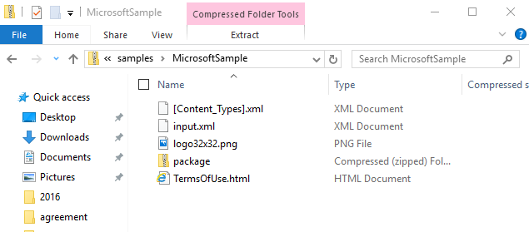

Here is a sample zip file for your reference.



# Store your CRM AppSource Package to Azure storage and generate a URL with SAS key

To maintain security of your files, we are asking all partners to store their CRM AppSource package file in an Azure blob storage account and use a SAS key to share it. We will retrieve the package file from your Azure storage location for certification and to use it for AppSource trials.

Here are the steps to upload your package to blob storage.

1. Go to <http://azure.microsoft.com> and create a free trial or pay as you go account.
2. Login to Azure portal <http://portal.azure.com/>
3. Create a new Storage Account by clicking the + New and going to Data + Storage 🡪 Storage account

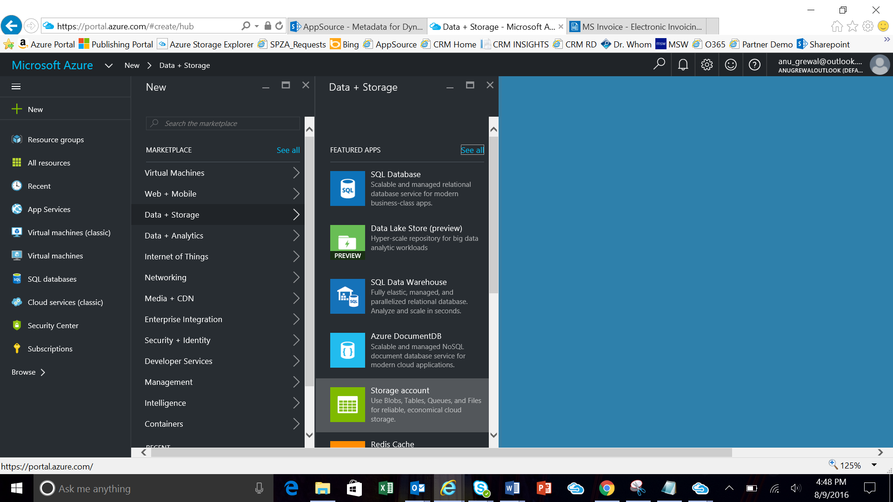

Enter a Name and Resource Group name and click “Create” button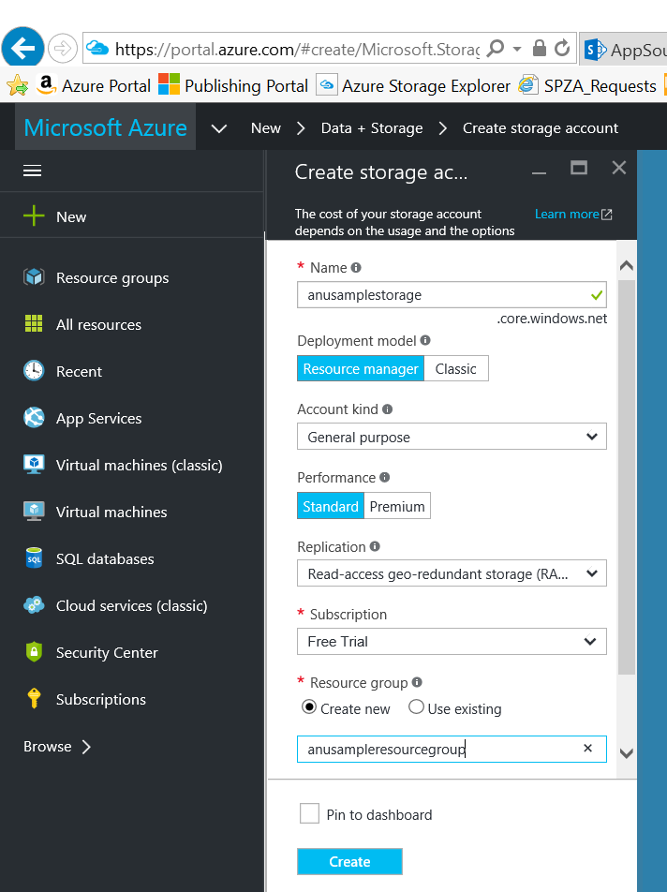

Navigate to your newly created resource group and create a new Blob container.

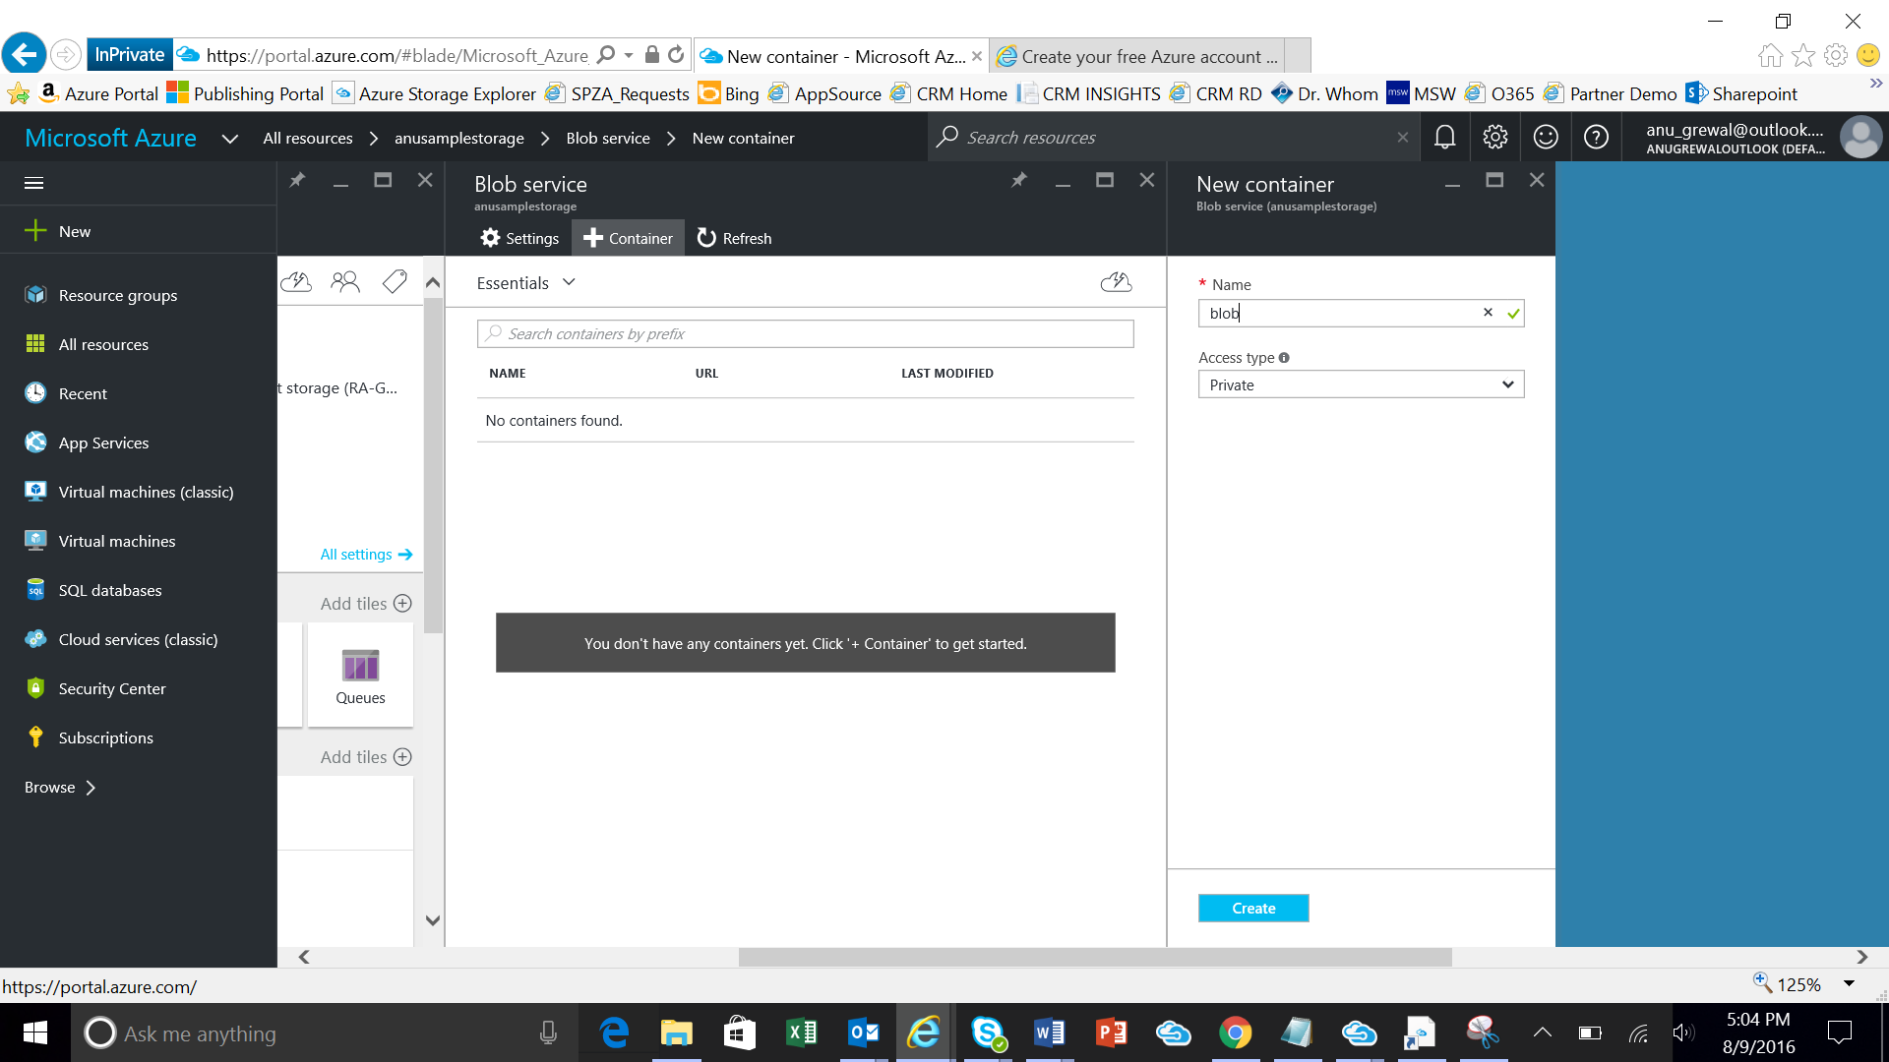

1. Download and install the Microsoft Azure Storage Explorer from here: <http://storageexplorer.com/>
2. Open Storage Explorer and use the icon 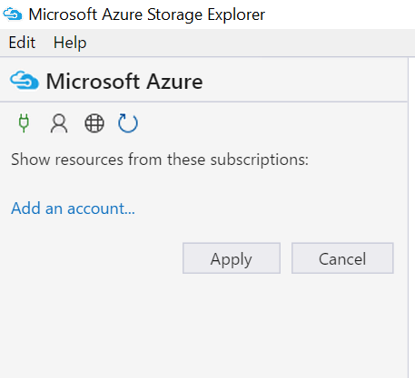 to connect to your Azure storage account
3. Navigate to the blob container you created and click Upload to add your package zip file

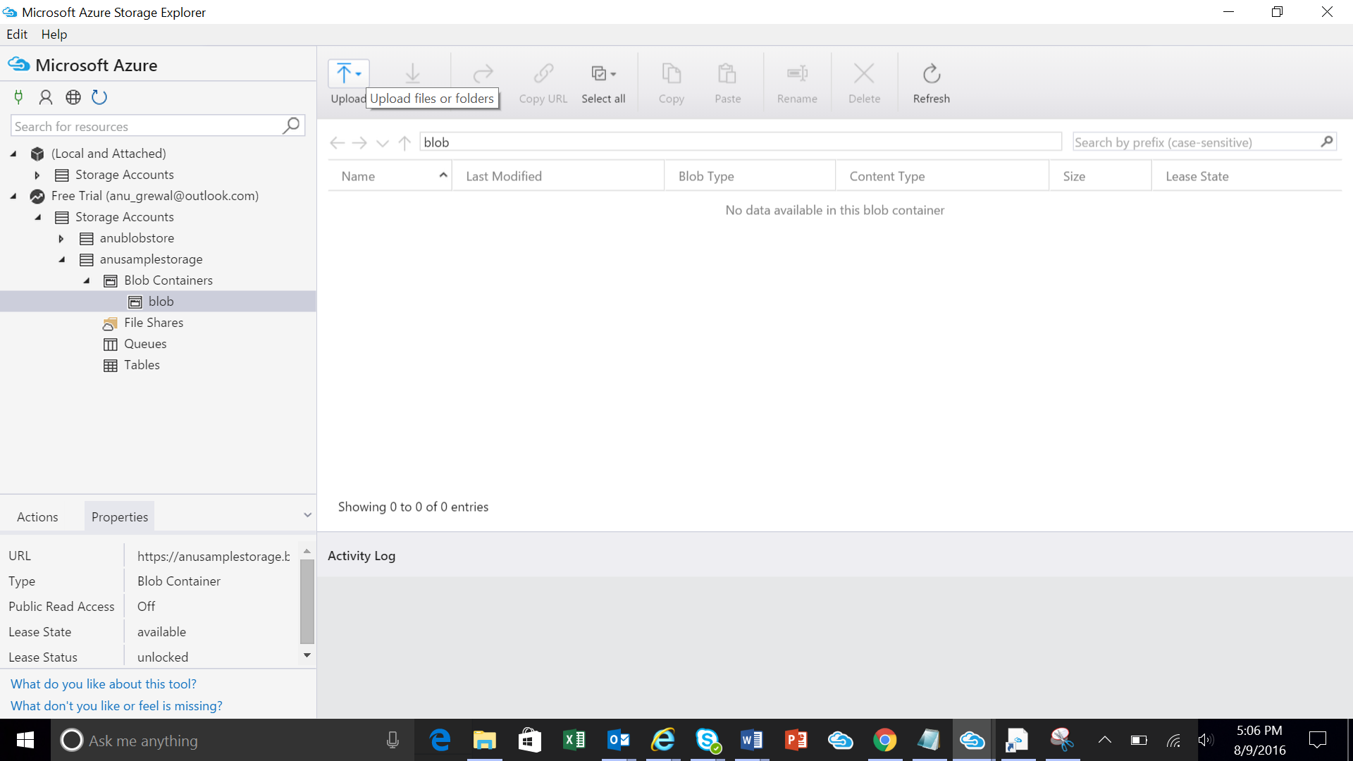

1. Right click on your file and go to “Get Shared Access Signature”

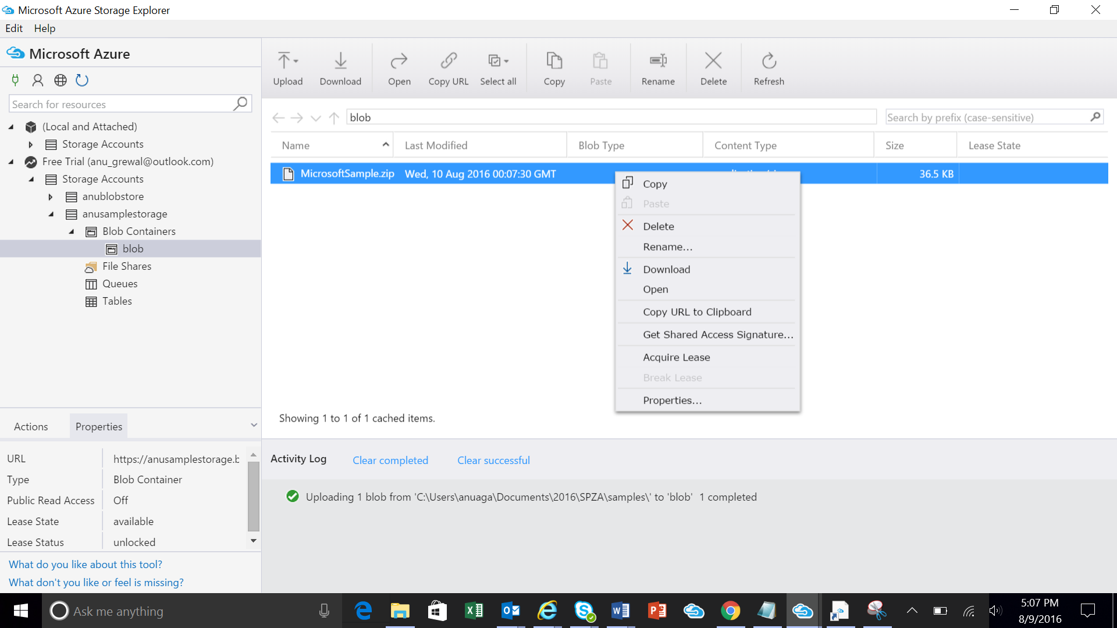

1. Modify the Expiry date to make the SAS active for a month and click Create

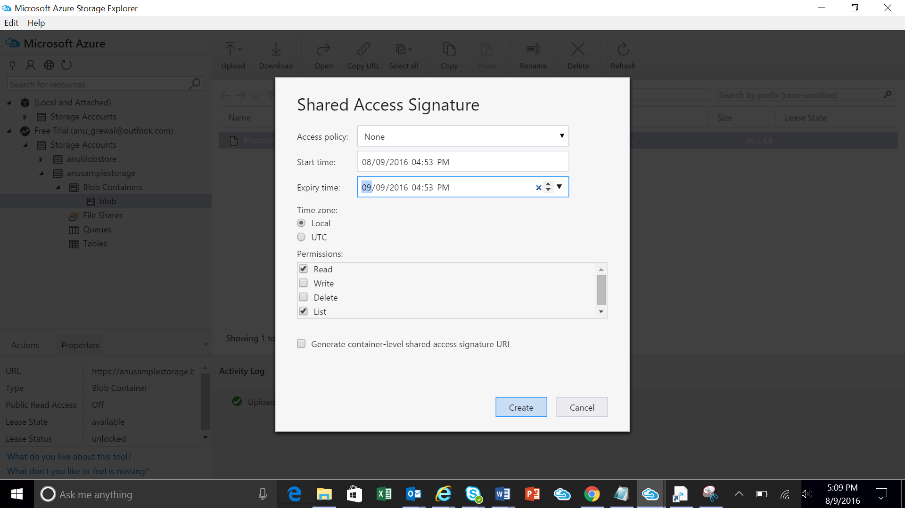

1. Copy the URL field and save it for later. You will need to enter this URL in the below step CRM Package

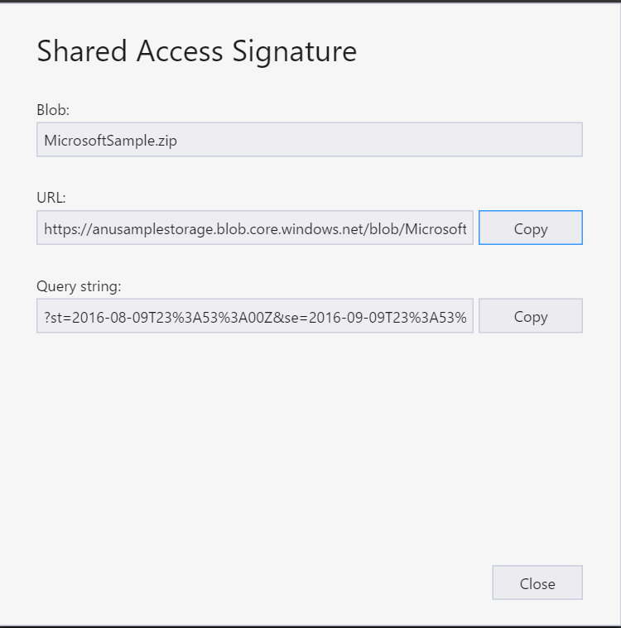

# Setup your application in the Publishing Portal

You are now ready to setup your application in the publishing portal.

## Sign in to the Publishing Center

Login to the publishing center using the account created in the step above “Dev Center Account Setup” or as a co-admin here: <https://publish.windowsazure.com>.

## Add an application and enter company/publisher information

After login, you will land at the Home page as shown in the screenshot below. From the left hand side panel, click on crm package.

**Note**: We are actively working on improving the experience. For now we would request you to use the left navigation panel to create your application.

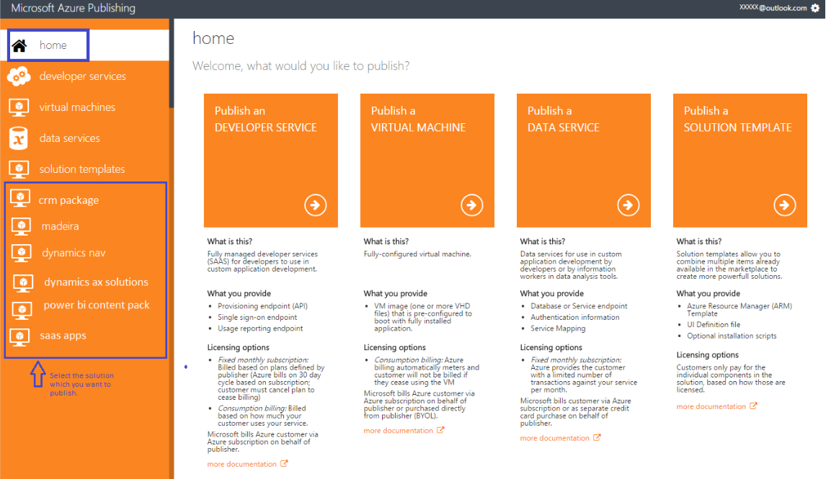

Enter an application title and click on the button "CREATE A NEW CRM PACKAGE OFFER.”

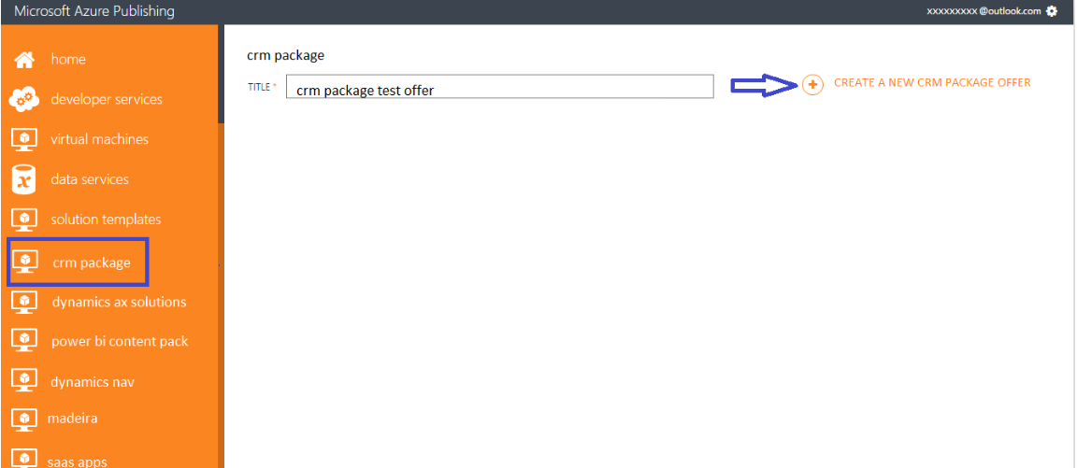

Click “Tell us about your company” and enter values for Short Name, Website, and Namespace. Note: The publisher namespace cannot be changed once an app is staged or live.

Change CSP (Cloud Solution Providers) Reseller Incentive to “No.” This is not relevant to AppSource.

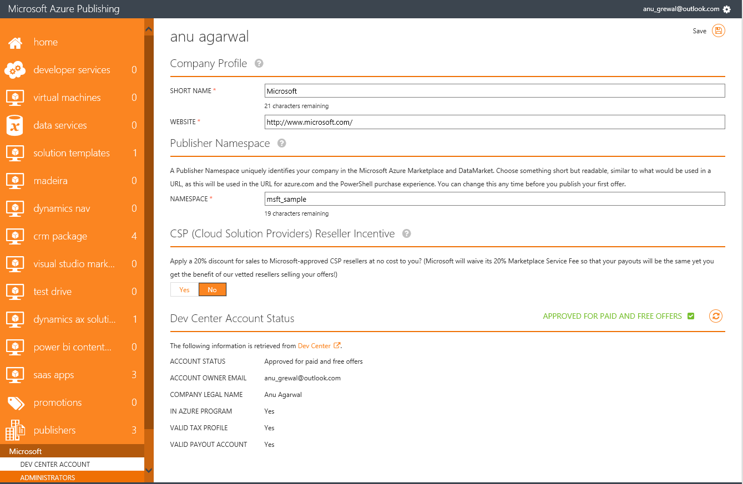

Only the SHORT NAME field is displayed in AppSource. See Image below for where it is displayed.

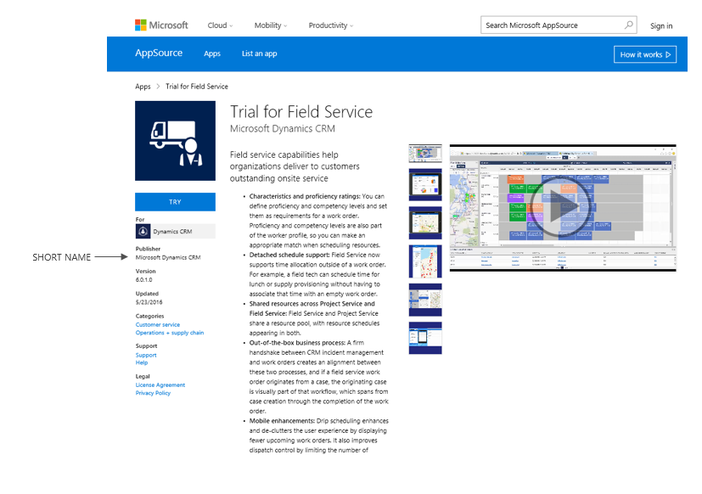

## Enter the information in the CRM PACKAGE section

Click on “crm package” from the left hand menu and choose the application you created above by clicking on the NAME field.

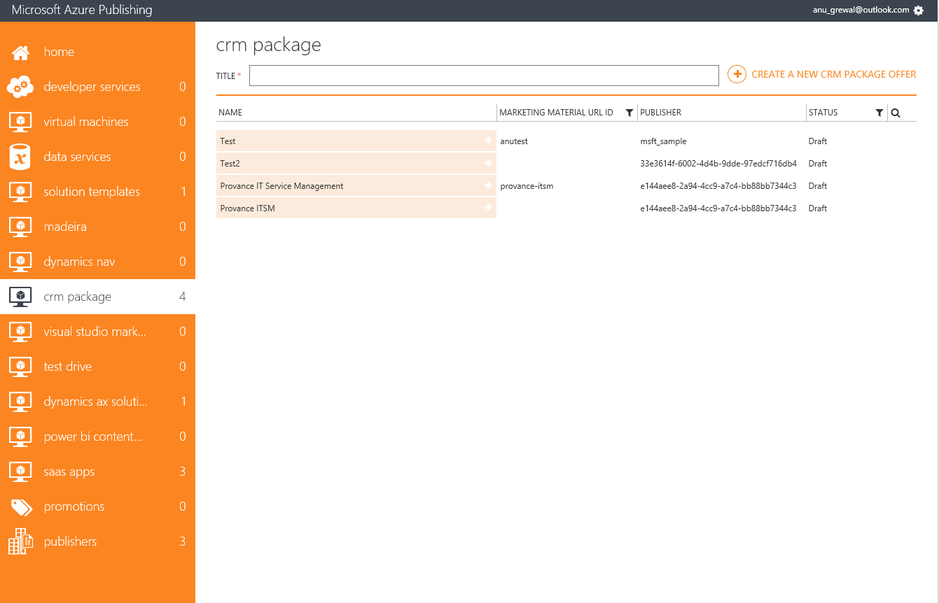

Fill in all the details for your application using the below guidelines.

### Offer Identifier

Enter a unique value to identify your offer. This is not displayed in AppSource.

### Application Info

|  |  |
| --- | --- |
| **Field** | **Details** |
| What is the base license model of your App | Indicate the base license model of your application. The license model determines how a customer will see your application in the CRM Admin center. Resource types are instances per quantity. User Types are only one pre-tenant. |
| Does your application require S2S outbound and CRM Secure Store Access? | Indicate if your application requires configuration of CRM Secure Store or S2S outbound access. Note: This requires specialized permission from CRM during the certification phase. You will be contacted to complete additional steps to support this. |
| Will your application subscribe to CRM Life Cycle Events? | Indicate if your application would subscribe to CRM Life Cycle Events. Integration with CRM Life Cycle events requires you to provide dedicated service that is registered with CRM and special agreement with Microsoft. *Note: This requires specialized permission from CRM during the certification phase. You will be contacted to complete additional steps to support this.* |
| Application Configuration URL | Enter the URL of the configuration page that should be presented to the end user to configure this application. |

### CRM Package

|  |  |
| --- | --- |
| **Field** | **Details** |
| File name of your package | The file name you created in the above step when creating your CRM AppSource Package. In the above example it is “MicrosoftSample.zip.” |
| URL of your package location | This is the URL to the Azure Storage account that contains the package file name specified above. It is the URL created in Step 9 of the section above Store your CRM AppSource Package to Azure storage and generate a URL with SAS key |
| Is there more than one CRM Package in your package file | If your application has more than one CRM Package, include all the packages necessary in the zip file that you have uploaded to the package location specified above. |

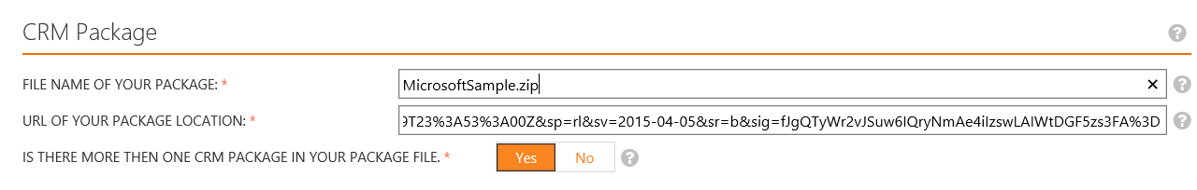

### CRM Package Availability

In this section select what regions of CRM your package will be made available to. For information on which regions serve which countries, please see the link: <http://o365datacentermap.azurewebsites.net/>

Note: US GOV Cloud indicates whether this package is deployable to customers in US Gov Cloud or not. *** THIS REQUIRES SPECIAL PERMISSION and VALIDATION DURING CERTIFICATION ***

### Marketplace Listing Details

#### Industries

AppSource allows the customers to select a product based on the industries that they belong to or industries they are targeting for. This field is used for sorting apps based on industry that a particular customer is interested. Publisher can select up to 2 industries for the application. Below is the universal list of Industries that AppSource.

​​["Agriculture",  "ArchitectureEngineering",  "Education",  "FinancialService",  "Government",  "NationalandPublicSecurity",  "HealthCareLifeSciences",  "HospitalityandTravel",  "Manufacturing",  "MediaandEntertainment",  "Nonprofits",  "ProfessionalServices",  "RealEstate",  "RetailandConsumerGoods", "Distribution", "Telecommunications"]

#### Categories/Sub-Categories

Publisher can select up to 2 categories/subcategories per application. This feature allows the customers to select the product based on the categories that they need to search an application. This field is used for sorting the applications based on the categories which are different from the categories in the Azure portal. This is a mandatory field.

​Values for Categories:

[“Sales”, “CustomerServices”, “Marketing”, “OperationSupplyChain”, “HumanResources”, “Finance”, “Collaboration”, “Analytics”, “Productivity”, “Gamification”, “ ITandAdministration”]​​

Values for Sub-Categories:

​["CompensationManagement", "Contractmanagement", "Ecommerce", "ForecastingTerritoryManagement", "Geolocation", "PartnerManagement", "Productivity", "Quotes_Orders_Invoices", "Salesintelligence", "AgentProductivity", "Communities", "FieldServices", "Surverys", "Telephony", "DemandGeneration", "WebinarsandEvents", "SocialMedia", "OnlineAdvertising", "MobileMarketing", "MarketingResourceManagement", "WebsitesPortals", "DataMigration", "Accounting", "PaymentProcessing", "TimeExpense", "Communication", ContenetManagement", "EmailCalendar", "Other"]

Please make sure, your sub-categories match to the categories you select.   
For e.g. If your application  
Categories:

["Sales"]

Sub-Categories:

[“CompensationManagement”]

| **Category** | **Value in JSON** | **Sub Categories** | **JSON Value** |
| --- | --- | --- | --- |
| Sales | Sales | Compensation Management | CompensationManagement |
| Contract management | Contractmanagement |
| ecommerce | ecommerce |
| Forecasting & Territory Management | Forecasting&Territories |
| Geolocation | Geolocation |
| Partner Management | PartnerManagement |
| Productivity | Productivity |
| Quotes/Orders/Invoices | Quotes/Orders/Invoices |
| Sales intelligence | Salesintelligence |
| Other | Other |
| Customer Service | Customer Service | Agent Productivity | AgentProductivity |
| Communities | Communities |
| Field Services | FieldServices |
| Surveys | Surveys |
| Telephony | Telephony |
| Other | Other |
| Marketing | Marketing | Demand Generation | DemandGeneration |
| Webinars and Events | WebinarsandEvents |
| Social Media | SocialMedia |
| Online Advertising | OnlineAdvertising |
| Mobile Marketing | MobileMarketing |
| Marketing Resource Management | MarketingResourceManagement |
| Websites & Portals | Websites&Portals |
| Other | Other |
| Operations & Supply Chain | Operations & Supply Chain |  |  |
| IT & Administration | IT & Administration | Data Migration | DataMigration |
| HR | HumanResources |  |  |
| Finance | Finance | Accounting | Accounting |
| Payment Processing | PaymentProcessing |
| Time & Expense | Time&Expense |
| Other | Other |
| Collaboration | Collaboration | Communication | Communication |
| Content Management | ContentManagement |
| Analytics |  |  |  |
| Productivity |  | Email & Calendar | Email&Calendar |
| Gamification |  |  |  |

#### App Type

Choose Free if your app is always free for the user. For Free apps, AppSource will display the GET button. Choose Trial if your app is only available on a trial basis and the customer needs to contact you to extend the trial time or functionality. Trial apps will have a “TRY” button in AppSource.

#### Please Enter the Help Link to Your App

This is the URL for the help link displayed in AppSource on the app details page.

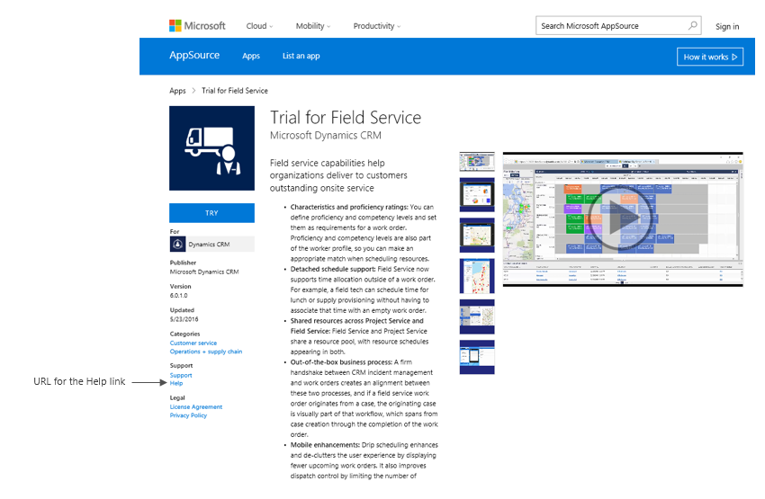

#### Countries your app is supported

The AppSource will provide the ISVs with a list of supported countries where the ISVs can sell their application. The ISVs will have to enter the countries which they have selected (from the list provided by AppSource) in a json format in this field. This field will thereby denote the list of countries where the ISV's application is available.

To know the codes of the countries [click here](https://globalready.azurewebsites.net/marketreadiness/OfficialCountryregion)

["AD", "AE", "AF", "AG", "AI", "AL", "AM", "AO", "AQ", "AR", "AS", "AT", "AU", "AW", "AX", "AZ", "BA", "BB", "BD", "BE", "BF", "BG", "BH", "BI", "BJ", "BL", "BM", "BN", "BO", "BQ", "BR", "BS", "BT", "BV", "BW", "BY", "BZ", "CA", "CC", "CD", "CF", "CG", "CH", "CI", "CK", "CL", "CM", "CN", "CO", "CR", "CU", "CV", "CW", "CX", "CY", "CZ", "DE", "DJ", "DK", "DM", "DO", "DZ", "EC", "EE", "EG", "ER", "ES", "ET", "FI", "FJ", "FJ", "FK", "FM", "FO", "FR", "GA", "GB", "GD", "GE", "GF", "GG", "GH", "GI", "GL", "GM", "GN", "GP", "GQ", "GR", "GS", "GT", "GU", "GW", "GY", "HK", "HM", "HN", "HR", "HT", "HU", "ID", "IE", "IL", "IM", "IN", "IO", "IQ", "IR", "IS", "IT", "JE", "JM", "JO", "JP", "KE", "KG", "KH", "KI", "KM", "KN", "KP", "KR", "KW", "KY", "KZ", "LA", "LB", "LC", "LI", "LK", "LR", "LS", "LT", "LU", "LV", "LY", "MA", "MC", "MD", "ME", "MF", "MG", "MH", "MK", "ML", "MM", "MN", "MO", "MP", "MQ", "MR", "MS", "MT", "MU", "MV", "MW", "MX", "MY", "MZ", "NA", "NC", "NE", "NF", "NG", "NI", "NL", "NO", "NP", "NR", "NU", "NZ", "OM", "PA", "PE", "PF", "PG", "PH", "PK", "PL", "PM", "PN", "PR", "PS", "PT", "PW", "PY", "QA", "RE", "RO", "RS", "RU", "RW", "SA", "SB", "SC", "SD", "SE", "SG", "SH", "SI", "SJ", "SK", "SL", "SM", "SN", "SO", "SR", "SS", "ST", "SV", "SX", "SY", "SZ", "TC", "TD", "TF", "TG", "TH", "TJ", "TK", "TL", "TM", "TN", "TO", "TR", "TT", "TV", "TW", "TZ", "UA", "UG", "UM", "US", "UY", "UZ", "VA", "VC", "VE", "VG", "VI", "VN", "VU", "WF", "WS", "XE", "XJ", "XK", "XS", "YE", "YT", "ZA", "ZM", "ZW"]

#### Languages supported by your app

The AppSource will provide the ISVs with a list of supported languages which the ISVs can use for developing their application. The ISVs will have to enter the languages which they have selected (from the list provided by AppSource) in a json format in this field. This field will thereby denote the list of languages that the ISV's application support.

To know the ISO 639-2 codes for the languages, please see the link [here](https://www.loc.gov/standards/iso639-2/php/code_list.php)

["aar", "abk", "ace", "ach", "ada", "ady", "afa", "afh", "afr", "ain", "aka", "akk", "alb", "ale", "alg", "alt", "amh", "ang", "anp", "apa", "ara", "arc", "arg", "arm", "arn", "arp", "art", "arw", "asm", "ast", "ath", "aus", "ava", "ave", "awa", "aym", "aze", "bad", "bai", "bak", "bal", "bam", "ban", "baq", "bas", "bat", "bej", "bel", "bem", "ben", "ber", "bho", "bih", "bik", "bin", "bis", "bla", "bnt", "bod", "bos", "bra", "bre", "btk", "bua", "bug", "bul", "bur", "byn", "cad", "cai", "car", "cat", "cau", "ceb", "cel", "cze", "cha", "chb", "che", "chg", "chi", "chk", "chm", "chn", "cho", "chp", "chr", "chu", "chv", "chy", "cmc", "cop", "cor", "cos", "cpe", "cpf", "cpp", "cre", "crh", "crp", "csb", "cus", "cym", "cze", "dak", "dan", "dar", "day", "del", "den", "deu", "dgr", "din", "div", "doi", "dra", "dsb", "dua", "dum", "dut", "dyu", "dzo", "efi", "egy", "eka", "ell", "elx", "eng", "enm", "epo", "est", "eus", "ewe", "ewo", "fan", "fao", "fas", "fat", "fij", "fil", "fin", "fiu", "fon", "fra", "fre ", "frm", "fro", "frr", "frs", "fry", "ful", "fur", "gaa", "gay", "gba", "gem", "geo", "ger", "gez", "gil", "gla", "gle", "glg", "glv", "gmh", "goh", "gon", "gor", "got", "grb", "grc", "gre", "grn", "gsw", "guj", "gwi", "hai", "hat", "hau", "haw", "heb", "her", "hil", "him", "hin", "hit", "hmn", "hmo", "hrv", "hsb", "hun", "hup", "hye", "iba", "ibo", "ice", "ido", "iii", "ijo", "iku", "ile", "ilo", "ina", "inc", "ind", "ine", "inh", "ipk", "ira", "iro", "isl", "ita", "jav", "jbo", "jpn", "jpr", "jrb", "kaa", "kab", "kac", "kal", "kam", "kan", "kar", "kas", "kat", "kau", "kaw", "kaz", "kbd", "kha", "khi", "khm", "kho", "kik", "kin", "kir", "kmb", "kok", "kom", "kon", "kor", "kos", "kpe", "krc", "krl", "kro", "kru", "kua", "kum", "kur", "kut", "lad", "lah", "lam", "lao", "lat", "lav", "lez", "lim", "lin", "lit", "lol", "loz", "ltz", "lua", "lub", "lug", "lui", "lun", "luo", "lus", "mac", "mad", "mag", "mah", "mai", "mak", "mal", "man", "mao", "map", "mar", "mas", "may", "mdf", "mdr", "men", "mga", "mic", "min", "mis", "mkd", "mkh", "mlg", "mlt", "mnc", "mni", "mno", "moh", "mon", "mos", "mri", "msa", "mul", "mun", "mus", "mwl", "mwr", "mya", "myn", "myv", "nah", "nai", "nap", "nau", "nav", "nbl", "nde", "ndo", "nds", "nep", "new", "nia", "nic", "niu", "nld", "nno", "nob", "nog", "non", "nor", "nqo", "nso", "nub", "nwc", "nya", "nym", "nyn", "nyo", "nzi", "oci", "oji", "ori", "orm", "osa", "oss", "ota", "oto", "paa", "pag", "pal", "pam", "pan", "pap", "pau", "peo", "per", "phi", "phn", "pli", "pol", "pon", "por", "pra", "pro", "pus", "qaa", "que", "raj", "rap", "rar", "roa", "roh", "rom", "ron", "rum", "run", "rup", "rus", "sad", "sag", "sah", "sai", "sal", "sam", "san", "sas", "sat", "scn", "sco", "sel", "sem", "sga", "sgn", "shn", "sid", "sin", "sio", "sit", "sla", "slk", "slo", "slv", "sma", "sme", "smi", "smj", "smn", "smo", "sms", "sna", "snd", "snk", "sog", "som", "son", "sot", "spa", "sqi", "srd", "srn", "srp", "srr", "ssa", "ssw", "suk", "sun", "sus", "sux", "swa", "swe", "syc", "syr", "tah", "tai", "tam", "tat", "tel", "tem", "ter", "tet", "tgk", "tgl", "tha", "tib", "tig", "tir", "tiv", "tkl", "tlh", "tli", "tmh", "tog", "ton", "tpi", "tsi", "tsn", "tso", "tuk", "tum", "tup", "tur", "tut", "tvl", "twi", "tyv", "udm", "uga", "uig", "ukr", "umb", "und", "urd", "uzb", "vai", "ven", "vie", "vol", "vot", "wak", "wal", "war", "was", "wel", "wen", "wln", "wol", "xal", "xho", "yao", "yap", "yid", "yor", "ypk", "zap", "zbl", "zen", "zgh", "zha", "zho", "znd", "zul", "zun", "zxx", "zza"]

#### Version of your app

This field is used to describe the version (Eg.- 1.0.0) of the application that the ISV will release in the AppSource.

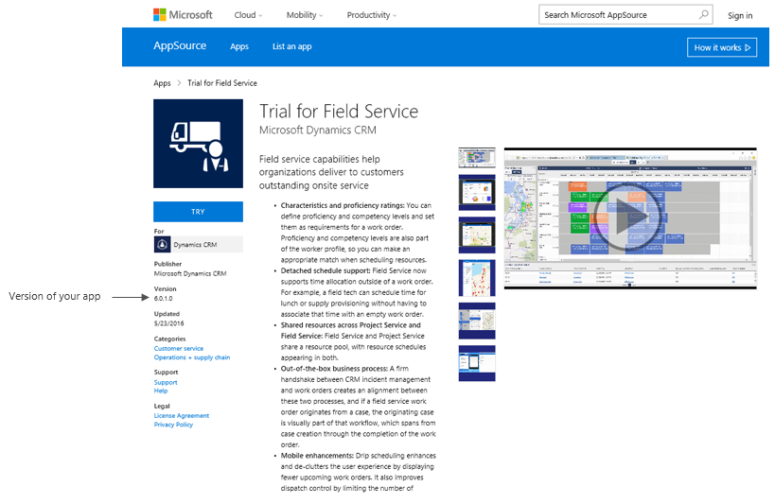

#### Version of platform for your app

This field is used to describe the version of platform your application supports, (E.g. platform 1.0).

#### Release date of your app

This field is used for entering the release date of the application in the AppSource. This field will be displayed in AppSource web experience. The date should be in mm/dd/yyyy format.

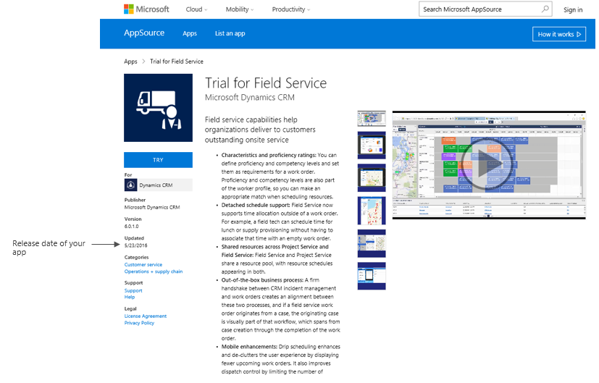

#### Hide key to test your offer in staging

This is the Key that will be used to preview your application in AppSource before going live. It’s a secrete key that can be used to preview the marketing page of your application.   
For e.g. “MyHideKey”

### Products that your app works with

Enter the different services that this application can work with.  
For. e.g. your application integrates with say Azure SDK 1.8, and VS2013 then your works with should be: Azure SDK 1.8, VS 2013.

### Search Keywords

AppSource allows customer to do search based on keywords. You can enter the set of keywords for which your application will be shown to the customers.

For e.g. if the application is "My Emailing Service"   
Emails, Mailing, Mail service are the keywords.

### Demo videos of your app

AppSource allows you to provide links to videos for your application. These will be shared with the end customers to get better insights of your product.

Documents related to your app

**Important**: Please upload only pdf files. We do not accept any other file format.

AppSource allows you to provide documents (in pdf format) for your application. These will be shared with the end customers to get better insights of your product.

### Logos and images for your app

These are displayed in the for your app once it is staged or live. See below for how the above videos, images, and documents are displayed in AppSource.

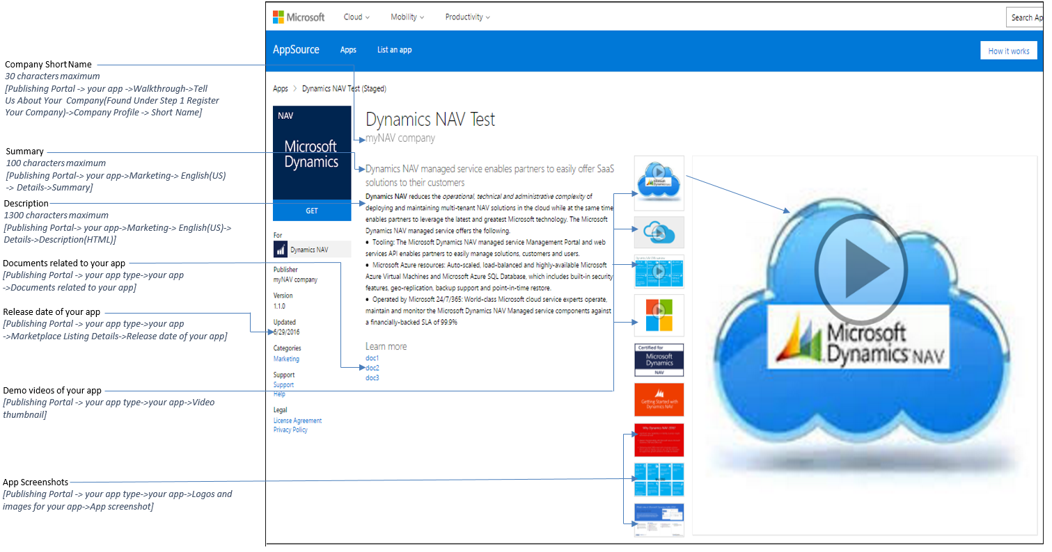

### Lead Management

We will provide leads to you when a user gets an application or requests trial. We can write leads into a number of different CRM systems (Dynamics CRM Online, Salesforce, etc.) or in CSV format in a blob provided by you.

From the LEAD DESTINATION dropdown control, select the appropriate option and then enter the required information as per the instructions given below.

None  
Select None if you do not want to use this feature.

##### Salesforce

{"objectIdentifier":"value"}

Click here to get instructions on how to get an objectIdentifier for your Salesforce instance.

##### Dynamics CRM Online

{"url":"value","authenticationType":"Office365","userName":"value","password":"value"}

Click here to get the instructions on how to configure Dynamics CRM Online for getting leads.

Sample value: {"url":"https://domain.crm.dynamics.com","authenticationType":"Office365","userName":"username@domain.onmicrosoft.com","password":"value"}

##### CSV file that will be stored in a Blob

{"connectionString":"value","containerName":"value"}

Click here to get the details for generating the connection string for CSV in Azure blob.

Sample value: {"connectionString":"DefaultEndpointsProtocol=https;AccountName=value;AccountKey=value","containerName":"value"}

##### Marketo

{"serverId":"Value","munchkinId":"Value","formId":"Value"}

Click here to get the instructions for setting up Marketo Lead Configuration to get leads.

##### Azure Table

{"connectionString":"DefaultEndpointsProtocol=https;AccountName=Value;AccountKey=Value;"}

Click here to get the instructions for setting up Azure storage account for getting leads in an Azure table.

## Enter the information in the PLANS section

**Note:** *The plan feature is not yet available. However, this step is required to push the application to staging or production*.

* Navigate to the "PLANS" tab from the left hand side panel.
* Click on the button "ADD A NEW PLAN". 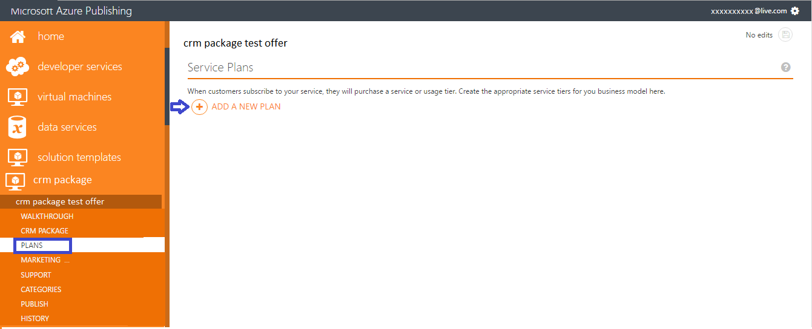
* A new dialogue box will open. In the Plan Identifier textbox enter the text "freetrial" and click on the ok button.   
  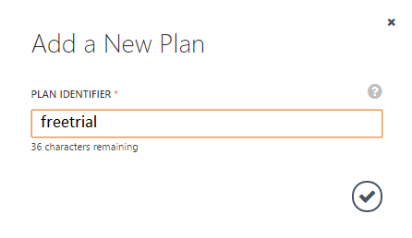 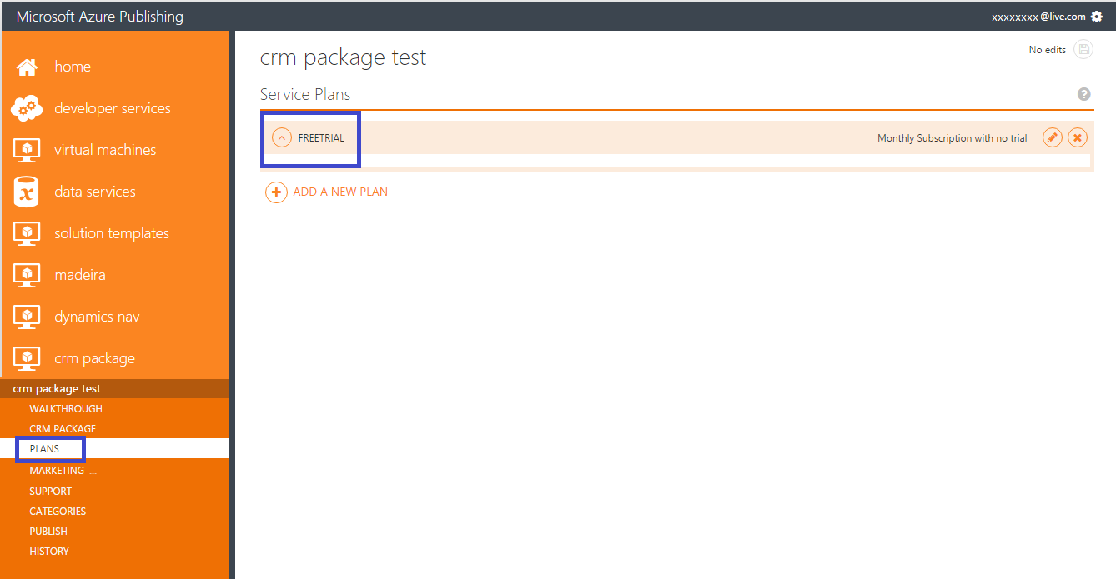

## Enter the information in the MARKETING section

**English is the default and only supported language**. Please ensure that all the information provided in the fields is in English. These information can be edited even after your application is live.Please refer to [this link](https://github.com/Azure/marketplacepublishing-documentation/wiki/How-does-the-marketing-content-get-displayed-in-the-Marketplace%3F) to find out how the marketing content entered in the Publishing portal get displayed in the AppSource.

* Navigate to the "MARKETING" tab from the left hand side panel.

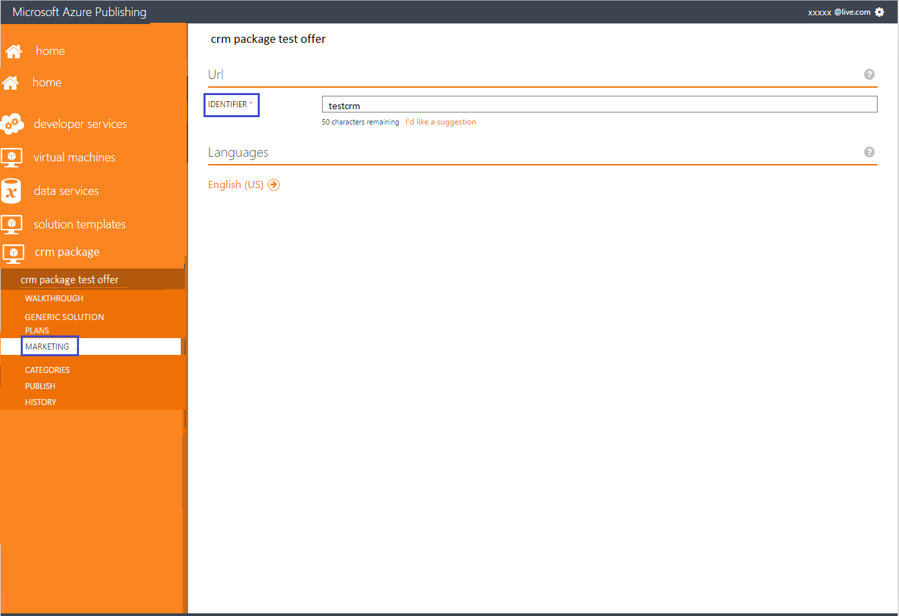

* Enter a marketing identifier under the URL section.
* After that click on the button "English(US)" under the Languages section.
* The system will take you to the Details tab once you click on the "English(US)" button.

### DETAILS

**Important:** *All the fields, except the hero icon and sample images, must be filled to be able to push the application to staging or production*.

**Note**: *You can use the following HTML tags to format the summary, long summary and description.  
Allowed HTML Tags are h1, h2, h3, h4, h5, p, ol, ul, li, a[target|href], strong, em, b, i*

* Upload logos of the required specifications (mentioned in the Publishing Portal) in PNG format, one for each size.

**Important**: *For now, you can use the logos provided here for Medium, Large and Small. Please use your app or company logo for the “Wide” logo, since this is displayed in the CRM Admin Center.*

Medium: 

Large: 

Small: C:\Users\anuaga\AppData\Local\Microsoft\Windows\INetCacheContent.Word\Small.png

*This step is required only to push the application to staging or production. We want to let you know that these logos will be ignored in the staging or in the production environment.*

**Please see the table below to know which content under this section will be displayed in the AppSource**

| **Section** | **Field** | **Will it get displayed in the AppSource?** |
| --- | --- | --- |
| Description | Title  (maximum 50 characters) | Yes |
| Summary  (maximum 100 characters) | Yes |
| Long summary  (maximum 256 characters) | No |
| Description(HTML)  (maximum 1300 characters) | Yes |
| Logos | Small, Medium, Large, Wide, Hero | No |

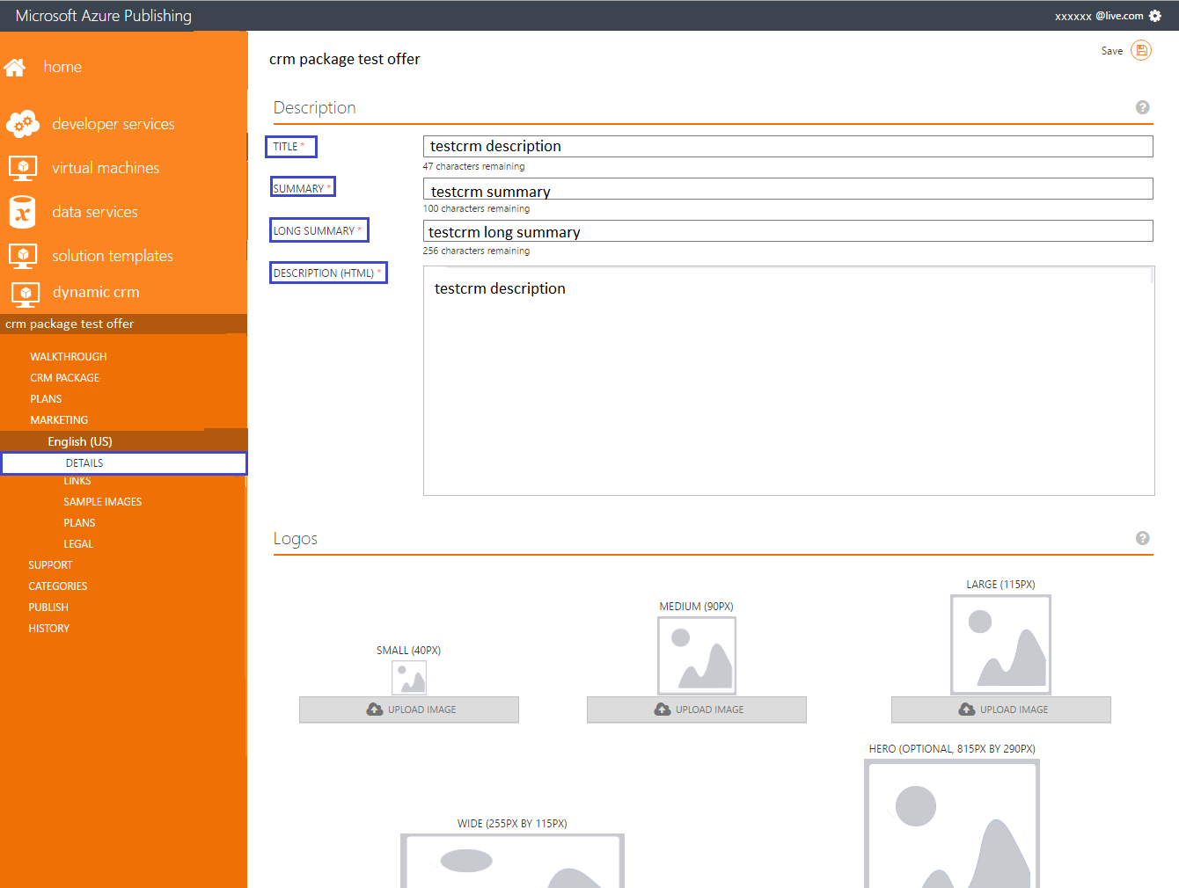

This is how this data is displayed in the application details page in AppSource.

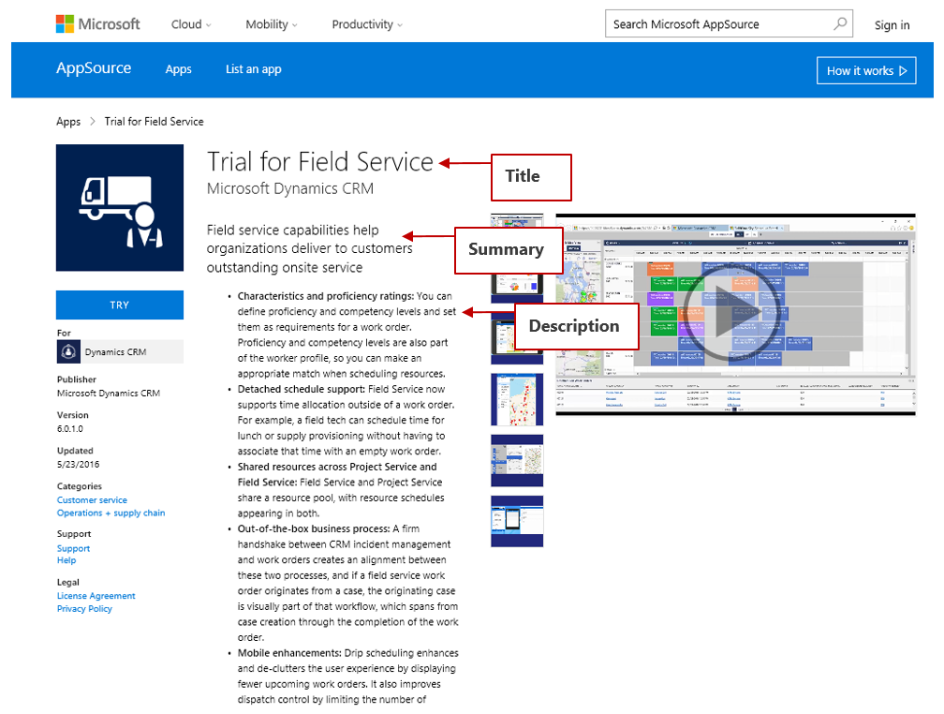

### LINKS

**Note**:*This step is required only to push the application to staging or production. We want to let you know that these link(s) will be ignored in the staging or in the production environment. However, you need to complete this step in order to proceed to staging or production from the Publishing portal. We are sorry for the inconvenience caused.*

* Navigate to the "LINKS" tab from the left hand side panel.
* Enter a name and an URL for each link.

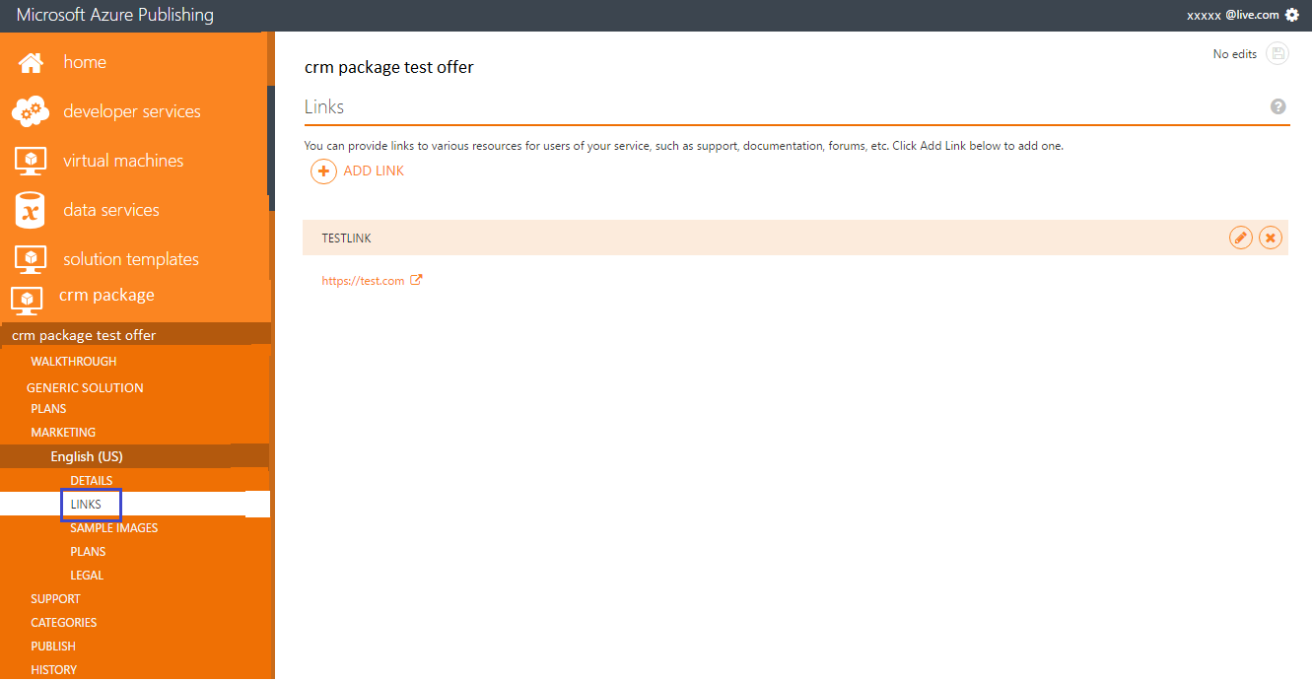

### SAMPLE IMAGES

**Note**: *We want to let you know that the sample images(s) provided at this step will be ignored in the staging or in the production environment. Hence please ignore this step. We are sorry for the inconvenience.*

### PLANS

**Note:** *The plan feature is not yet available. However, this step is required to push the application to staging or production*.

* Navigate to the "PLANS" tab under the Marketing tab->English(US) from the left hand side panel.
* Enter the text "Free plan" under Title.
* Enter the text "Free plan" under Summary.
* Enter the text "Free plan" under Description.

*This is what the plan details page in the Publishing portal looks like:*

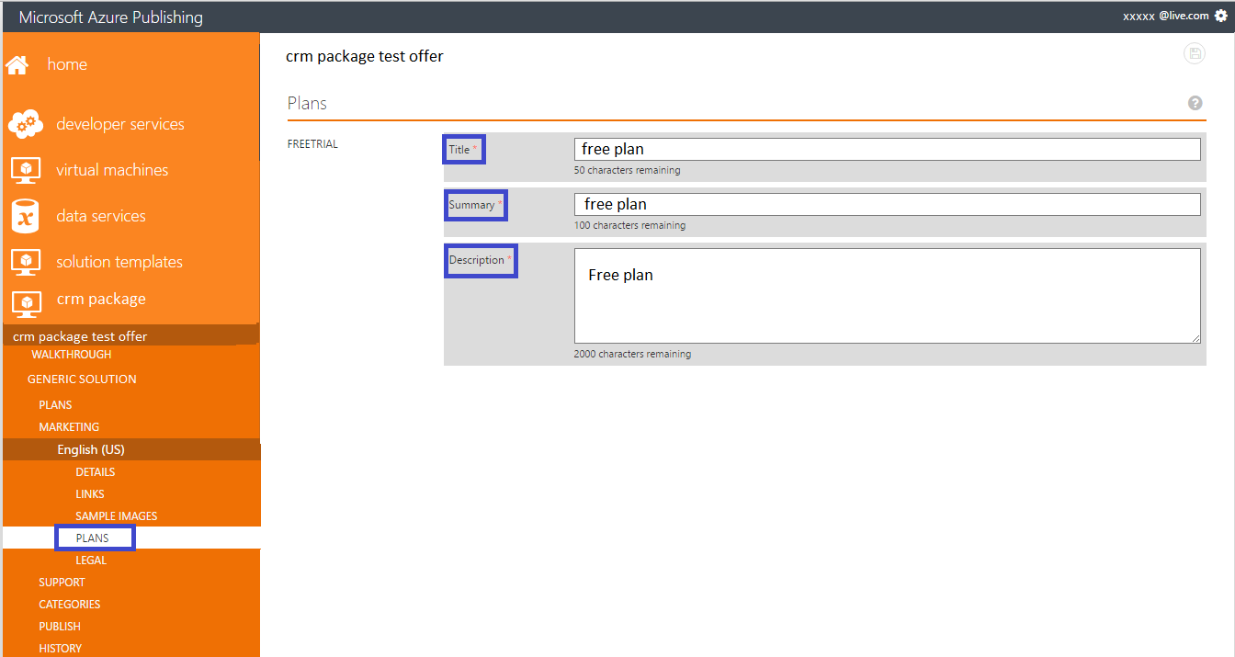

### LEGAL

The terms of use and privacy policy URL entered in this section are displayed in AppSource once the offer is staged of live.

* Navigate to the "LEGAL" tab from the left hand side panel.
* Provide a link to your policies or terms of use in the "PRIVACY POLICY URL" text box.
* Enter or paste the terms in the large "Terms of Use" text box.

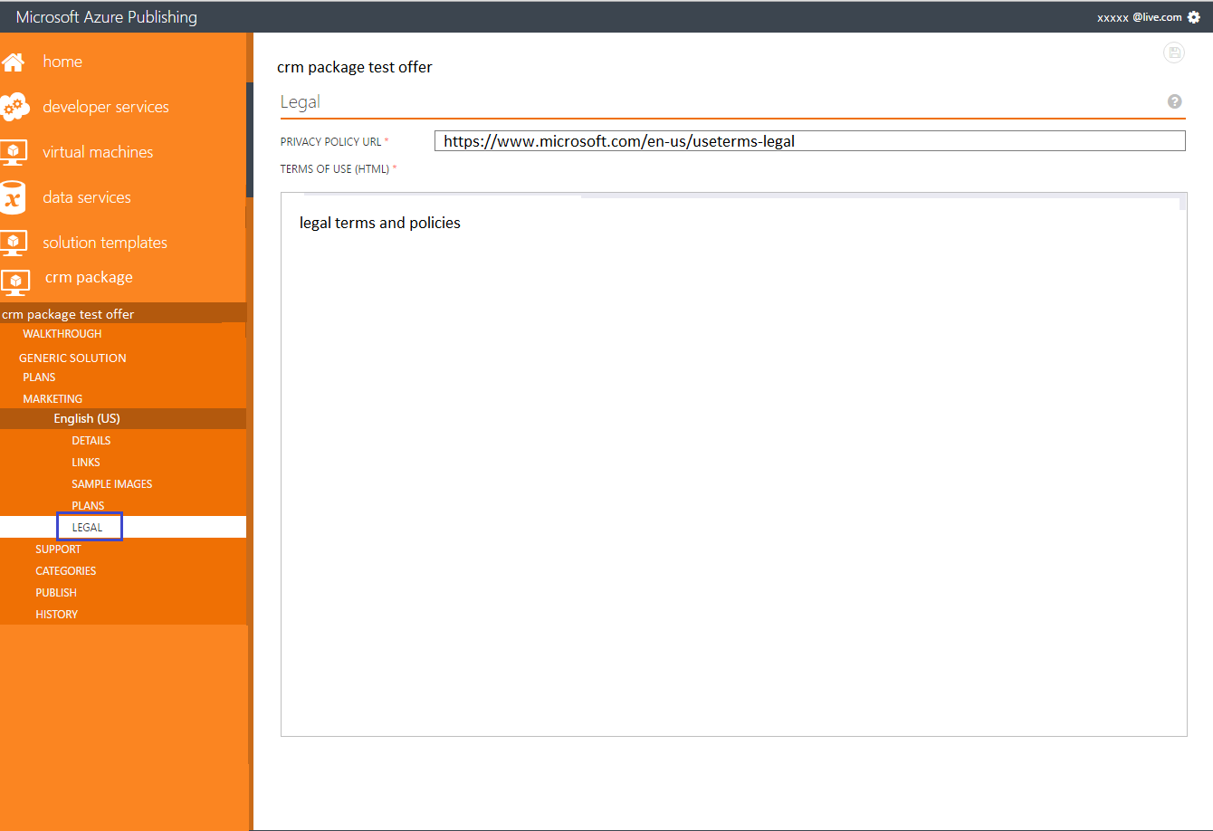

Where these are displayed in AppSource:

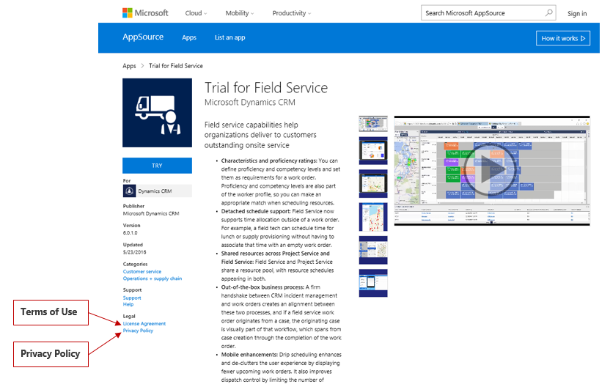

## Enter the information in the SUPPORT section

**Provide support information**

The contact details are used for internal communication between the partner and Microsoft only. Only the support URL will be visible to the customers.

* Navigate to the "SUPPORT" tab from the left hand side panel.
* Enter the engineering contact, customer support contact and a support URL.

**Please see the table below to know which content under this section will be displayed in the AppSource**

| **Section** | **Field** | **Will it get displayed in the AppSource?** | **Other information** |
| --- | --- | --- | --- |
| Engineering Contact | Name, Email, Phone | No | This contact listed here will receive an email each time a customer requests the solution in AppSource. |
| Customer Support | Support Contact  (Name, Email, Phone) | No |  |
| Support URL | Yes | [See the image below](https://github.com/Azure/marketplacepublishing-documentation/wiki/How-does-the-marketing-content-get-displayed-in-the-Marketplace%3F#3-app-page) |

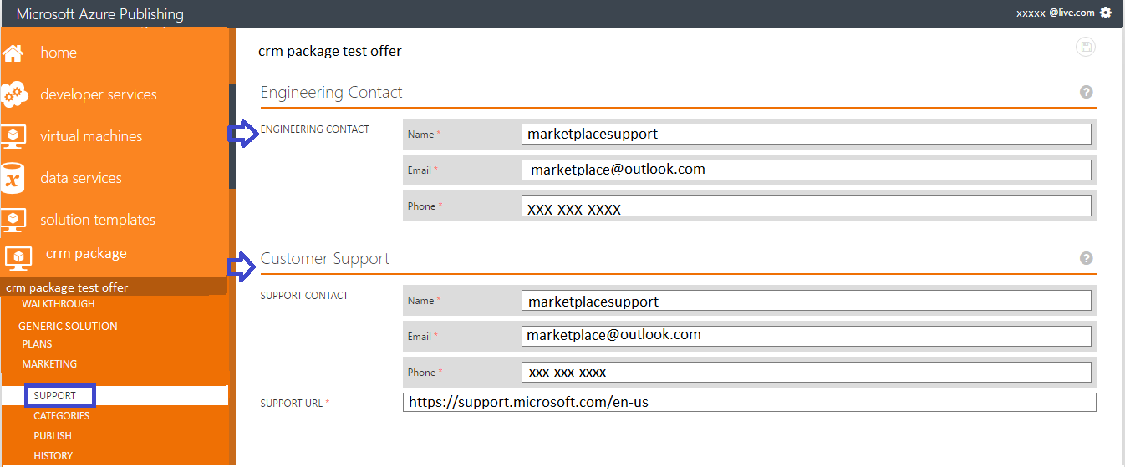

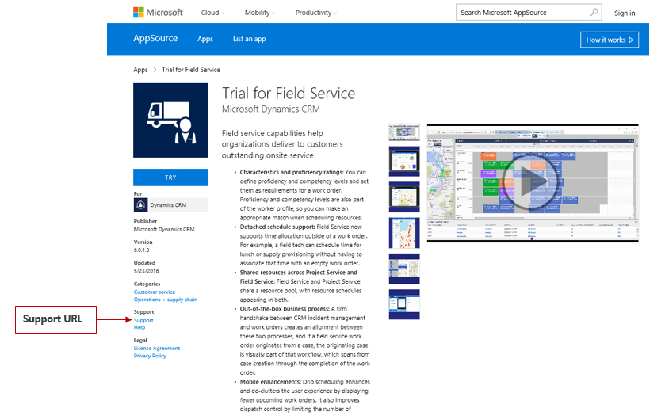

## Enter the information in the CATEGORIES section

**Choose the categories**

**Note:** *This step is required only to push the application to staging or production. We want to let you know that these selections will be ignored in the staging or in the production environment. However, you need to complete this step in order to proceed to staging or production from the Publishing portal. We are sorry for the inconvenience.*

Navigate to the "CATEGORIES" tab from the left hand side panel and select up categories.

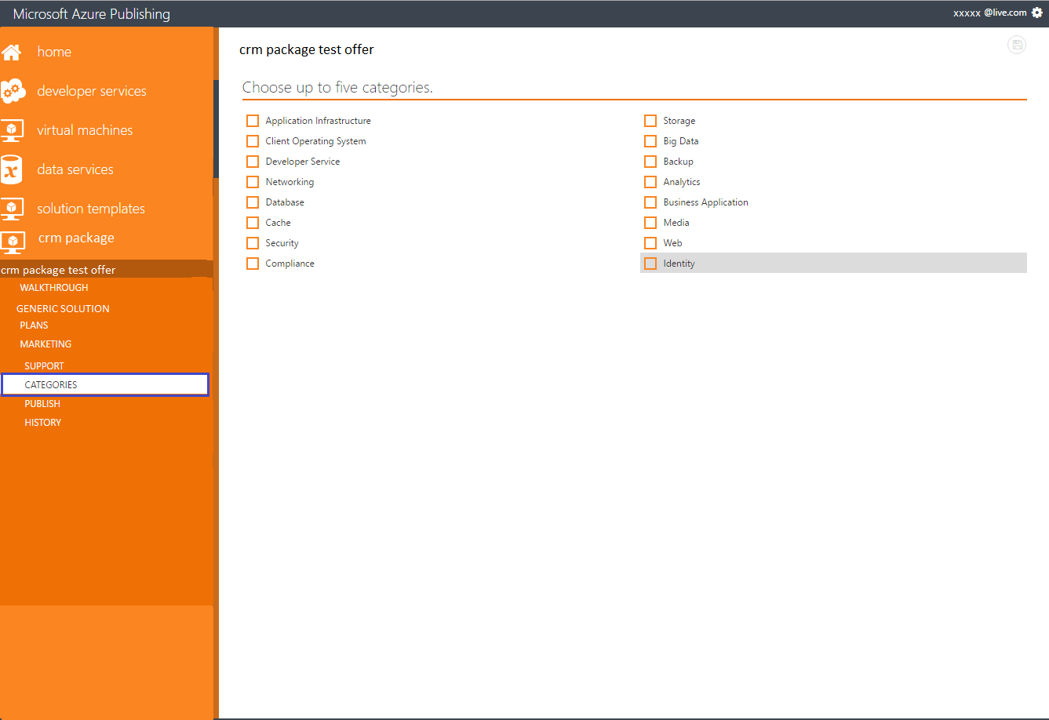

## Push to staging in the PUBLISH section

Staging means deploying your application in private preview where you can test the functionality before pushing it to production. To push your application in staging, navigate to the "PUBLISH" tab from the left hand side panel and click on the button "PUSH TO STAGING".   
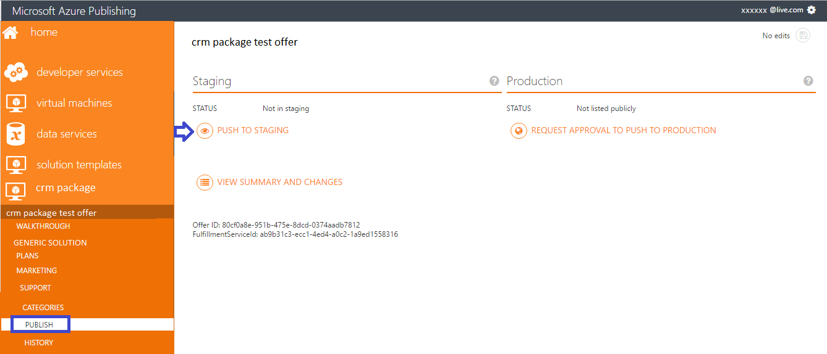  
  
A window will pop up asking for subscription. You do not need an Azure subscription for this. Simply enter 00000000-0000-0000-0000-000000000000 in the textbox and click on the "+" button. After that click on the ok button to add GUID.

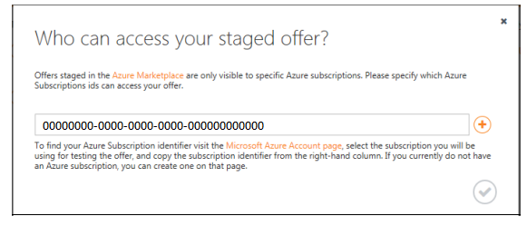  
  
Once done, the request will come to us for validation of your application. You can check the progress under the "PUBLISH" tab. If you find that an error is reported, then correct the error and push the application to staging again.

If you get to the below point showing the step CRMPackageCertification stopped at 50% that means you’ve cleared all errors and our validation team is working on certifying your app.

Congratulations! We will be in touch with you on the next steps.

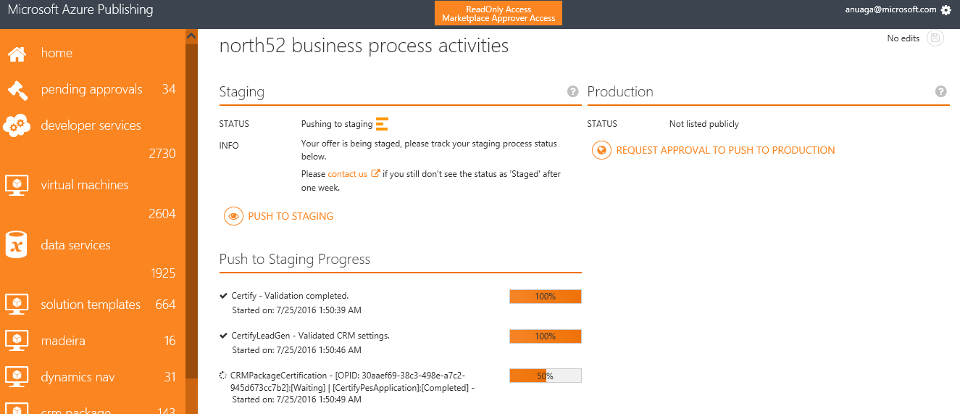

# Appendix A – Lead Management Setup

## Salesforce

Go to Setup



In the navigation bar go to Build->Customize->Leads->Web-to-Lead.

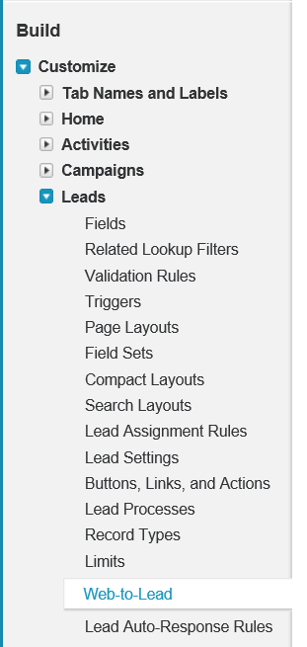

Click on “Create Web-to-Lead Form” button.

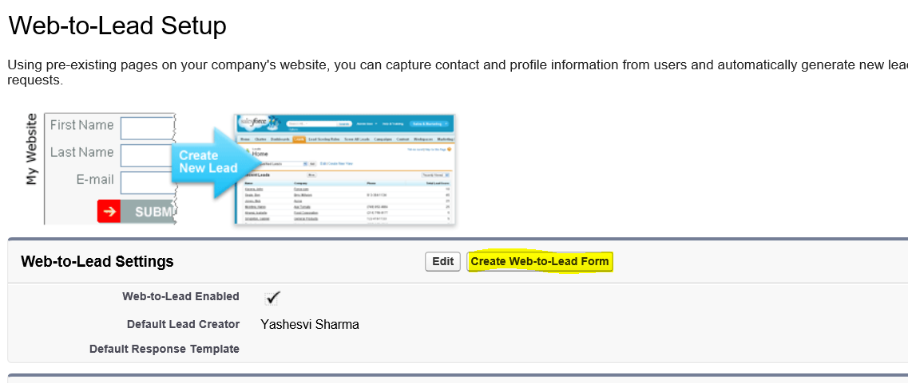

In the next page - don’t worry about the field in the form and click on “Generate”.

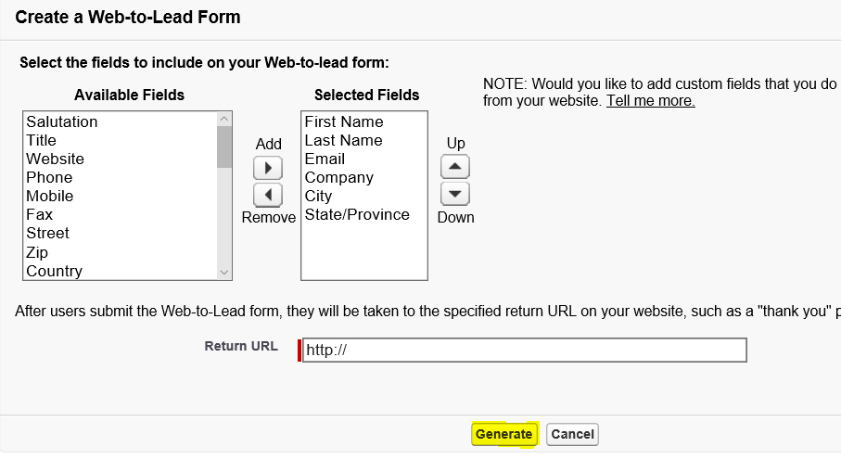

Copy the OID from the form and use it to generate the JSON for lead configuration.

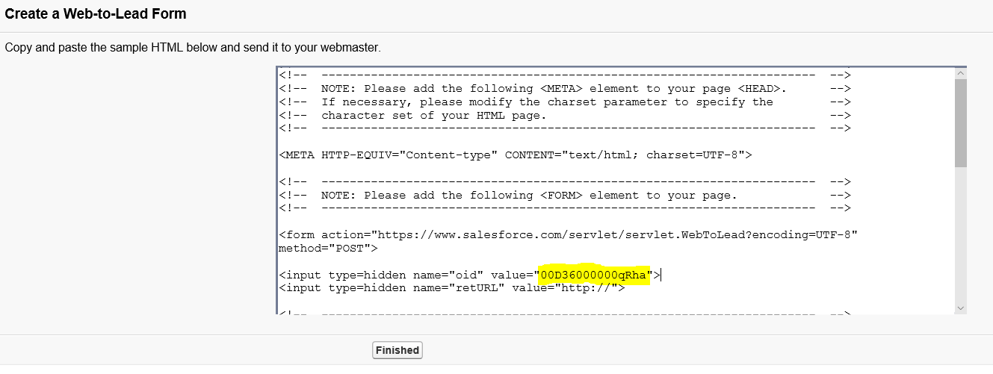

## Dynamics

This below steps provide instructions on how to setup your Dynamics CRM Online system so that Microsoft can provide you with sales leads from AppSource.

**User permissions required for performing the following steps:** you need to be an admin on your Dynamics CRM Online instance to install a solution and you need to be a tenant admin to create a new service account for lead service.

**Installing the solution:**   
1. Download Microsoft AppSource Lead Writer solution from

[**https://testdriveaccount.blob.core.windows.net/testdrivecon/MicrosoftMarketplacesLeadIntegrationSolution_1_0_0_0_target_CRM_6.1_managed.zip**](https://testdriveaccount.blob.core.windows.net/testdrivecon/MicrosoftMarketplacesLeadIntegrationSolution_1_0_0_0_target_CRM_6.1_managed.zip)

and save it locally.   
2. Go to Dynamics CRM online settings.   
(If you don’t see the options like in the image below, then you don’t have the required permissions)

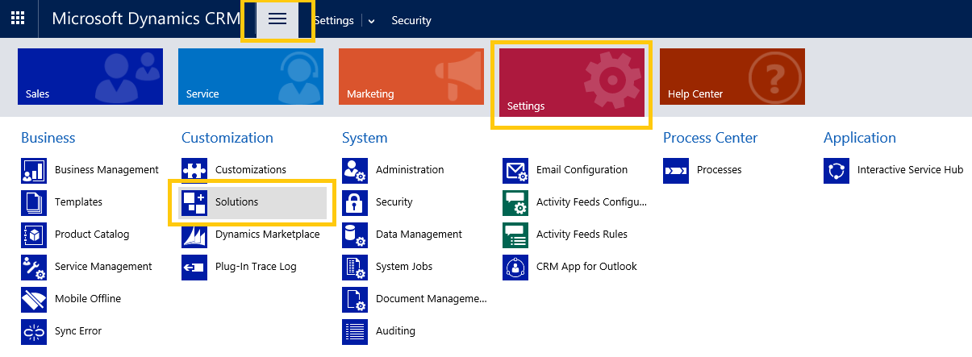

3. Click on Import, and select the solution that you downloaded in step 1.

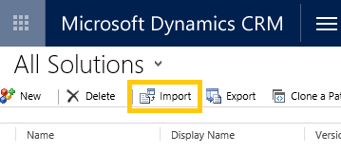  
  
4. Finish installing the solution.

**User permissions:**   
We need you to share service account information with us so that we can authorize to write leads into your Dynamics CRM instance. The steps below walk you through how to create the service account and permissions to assign.   
1. Go to [Microsoft Office 365 Admin Portal](https://go.microsoft.com/fwlink/?LinkId=225975)   
2. Click on “Admin” tile:   
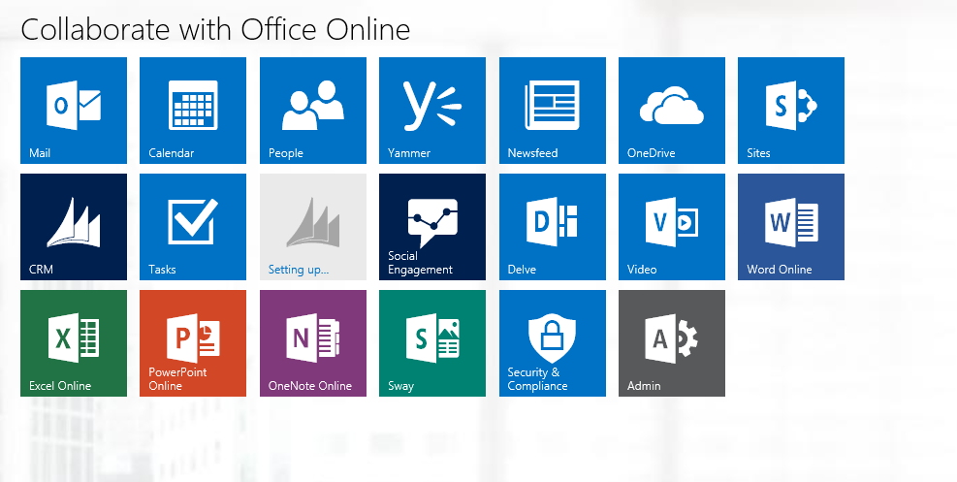  
  
3. Click on “Add a user”   
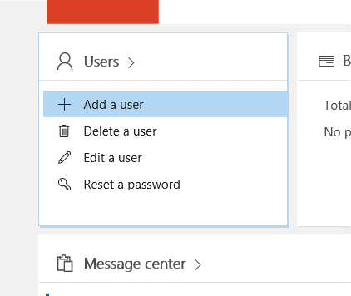

4. Create a new user for the lead writer service. Please ensure following

* Provide a password and uncheck “Make this user change their password when they first sign in”
* Select the role to be “User (no administrator access)”
* Select product license as shown below. (You will be charged for the license you select; the solution will work with Dynamics CRM Online Basic license as well)   
  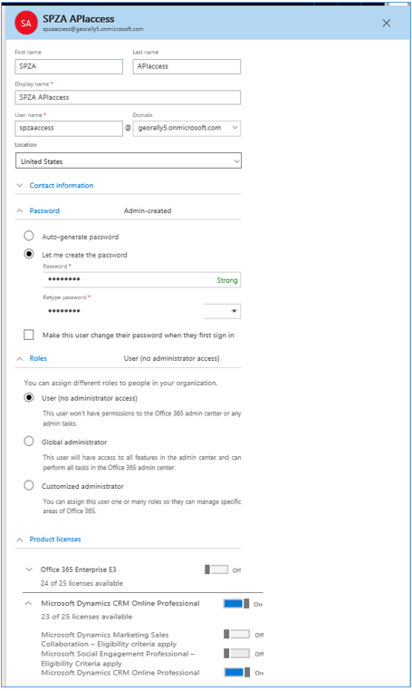

5.Go to Dynamics CRM online go to Settings->Security, and click on

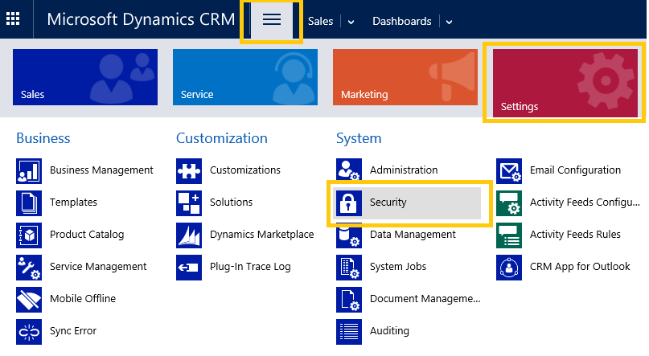

6.Select the user that you created in Step 4, click on Manage Roles in the top ribbon, and assign the role as shown below:

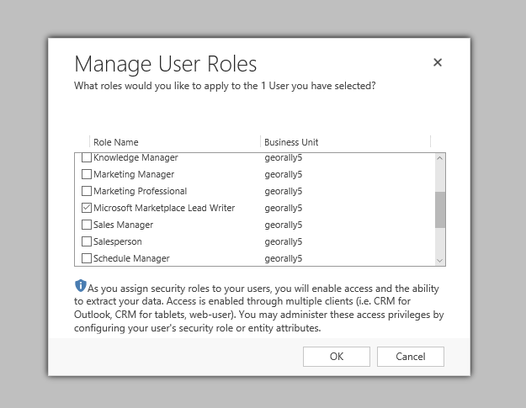

This role is created by the solution that you imported and has permissions to only write the leads and to know solution version for ensuring compatibility.

## CSV file that will be stored in a Blob

1. If you don’t have an Azure account, then click [here](https://azure.microsoft.com/en-us/pricing/free-trial/) to create one.
2. Once your account is ready, create a storage account. See screenshot below for instructions. Click [here](https://azure.microsoft.com/en-us/pricing/details/storage/) to know about storage pricing.

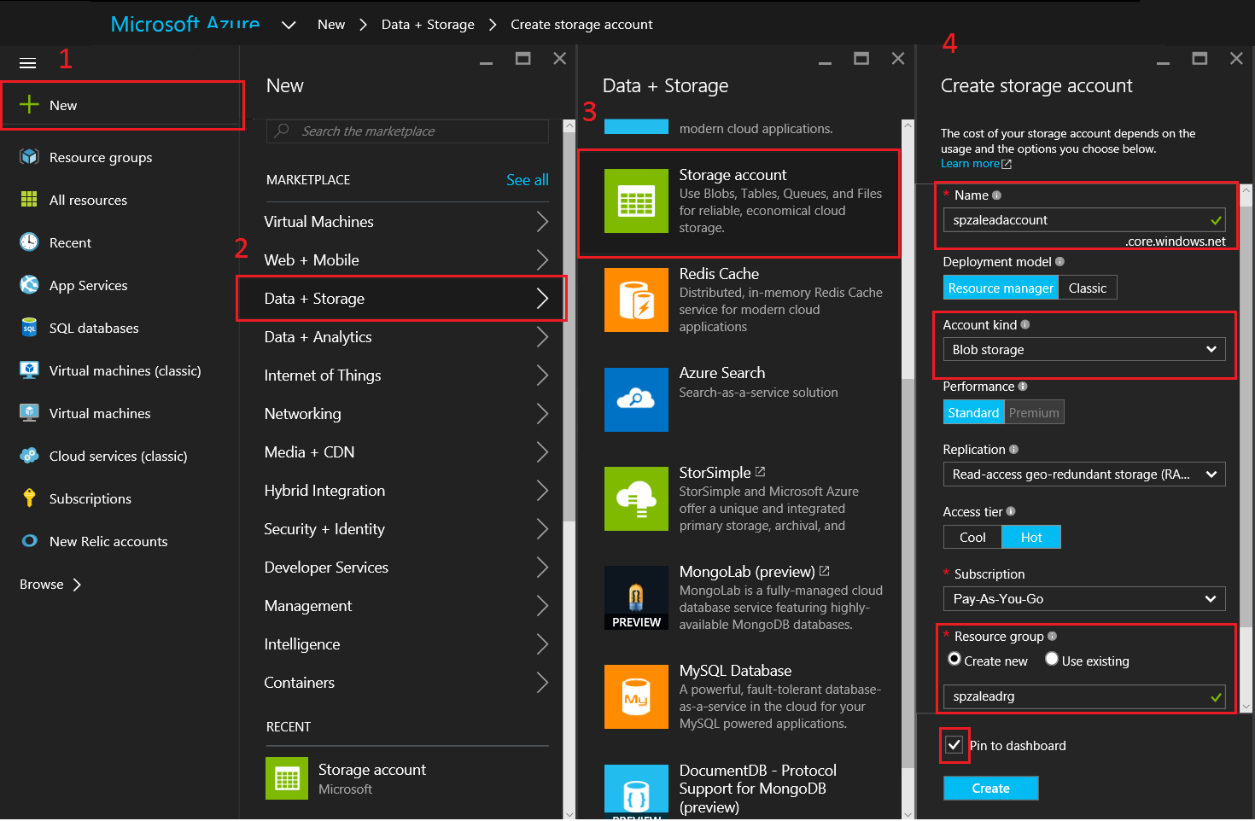

On step 4 above:  
• Provide a name for the storage account. Save this to fill in the connection string later.   
• Select account kind as “Blob storage”.   
• Create a new Resource group (you can use an existing recourse group as well, if you have one).   
• Select “Pin to dashboard”.   
• Click create.   
3. You will see the Azure storage that you just created in your Azure dashboard. ([https://portal.azure.com](https://portal.azure.com/))   
4. Click on the storage account and create a new Container. See below.

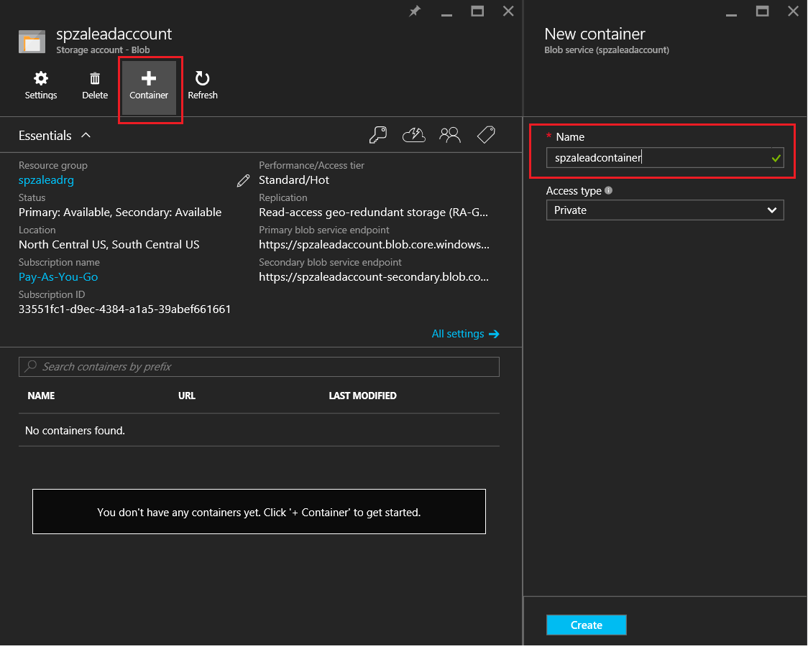

5.Click on the storage account and create a new Container. See below. Save the container name to fill it in the connection string later.

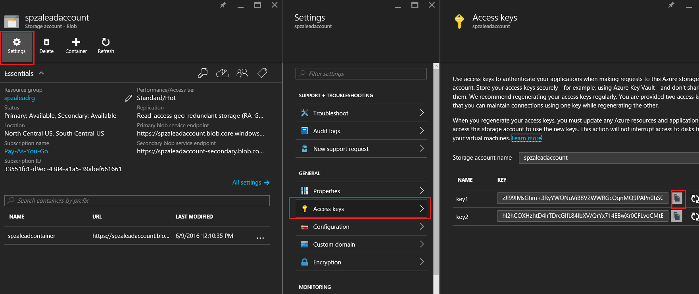

6.Create connection string as below:

{"connectionString":"DefaultEndpointsProtocol=https;AccountName=account name value from step 3;AccountKey=account key value from step 6","containerName":"container name value from step 5"}

**Sample final connection string**:

{"connectionString":"DefaultEndpointsProtocol=https;AccountName=spzaleadaccount;AccountKey=zJl99IMsGhm+3RyYWQNuViB8V2WWRGcIqnMQ9PAPn0hSOjbOQ8PUHegzQwngWHGD/gJ6tdFhUdUQeJNYoPMUCw==","containerName":"spzaleadcontainer"}

## Marketo

1. Go to “Design Studio” in Marketo.   
   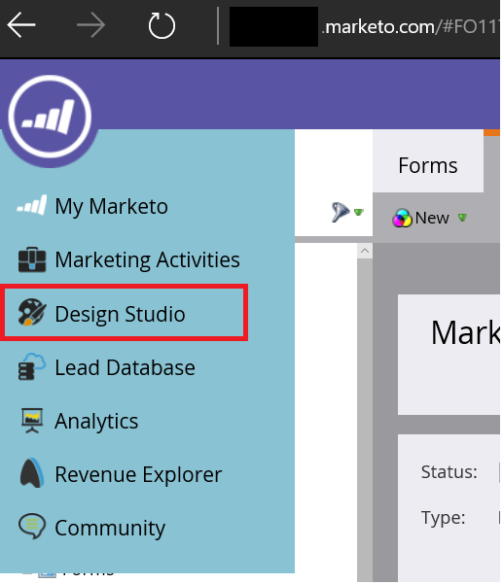
2. Click on “New Form”   
   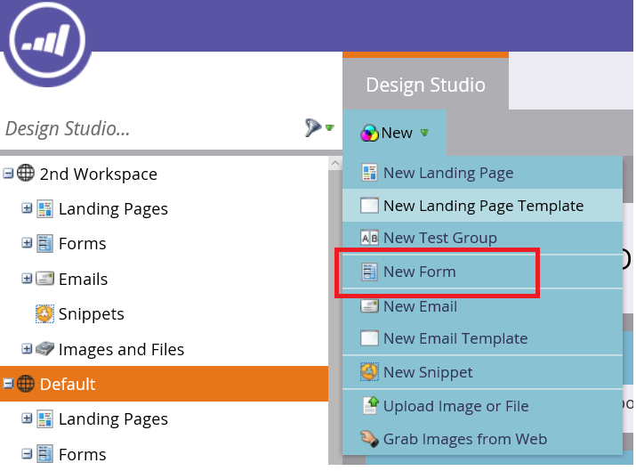
3. Fill the fields in the New Form pop-up   
   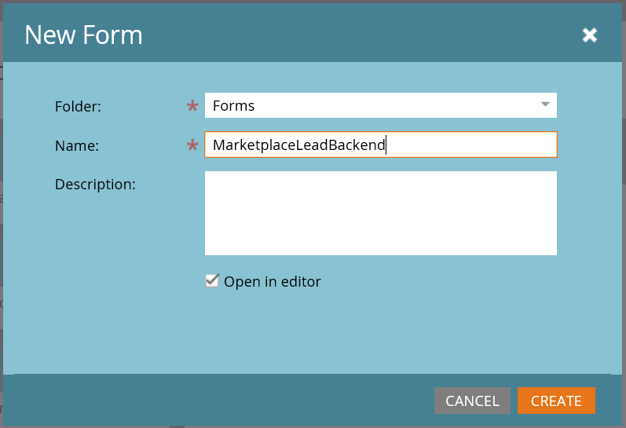
4. Click on “finish” in the next form. Don’t worry about the formatting or fields.   
   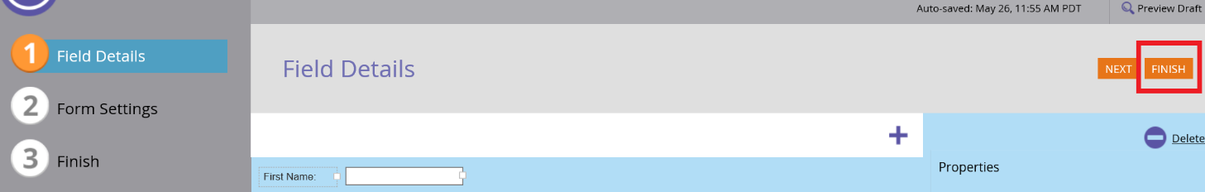
5. Approve and Close.
6. On the next page, go to   
   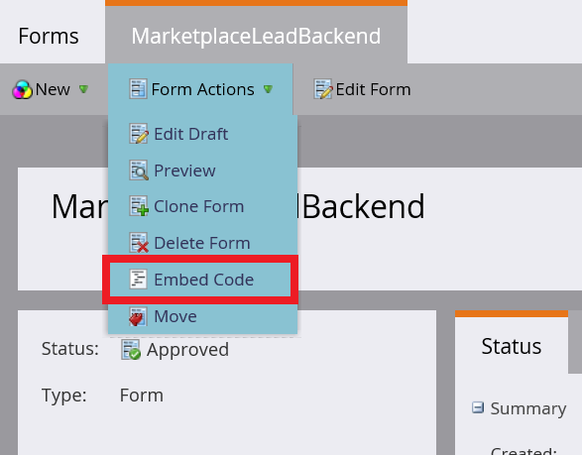
7. You will see text like below in the embed code:

<script src="//app-ys12.marketo.com/js/forms2/js/forms2.min.js"></script>   
<form id="mktoForm_1179"></form>   
<script>MktoForms2.loadForm("("//app-ys12.marketo.com", "123-PQR-789", 1179);</script>

1. Use the values available in the embed code to fill serverId, munchkinId, and formId in the JSON for your marketo instance.

Following will help you determine the Ids from sample data above.

serverId = **ys12**

munchkinId = **123-PQR-789**

formId = **1179**

1. Create the JSON as shown below:   
   {"serverId":"Value","munchkinId":"Value","formId":"Value"}

Sample: {"serverId":"ys12","munchkinId":"123-PQR-789","formId":"1179"}

Please ensure there are no spaces in the values you provide.

1. After your application is successfully pushed to staging you should see a test lead with GUIDs (Example: 52790e0b-14bf-46b2-85b0-214c6d295d56) in your Marketo. Seeing this lead confirms that yours leads are setup fine. If you do not see the lead please check if there are any rules preventing us from writing the lead or filtering the leads. If you still face issues, please use Azure table or CSV option.

## Azure Table

1. If you don’t have an Azure account, then click [here](https://azure.microsoft.com/en-us/pricing/free-trial/) to create one.
2. Once your Azure account is ready, create a storage account. See screenshot below for instructions.   
   Click [here](https://azure.microsoft.com/en-us/pricing/details/storage/) to know about storage pricing.

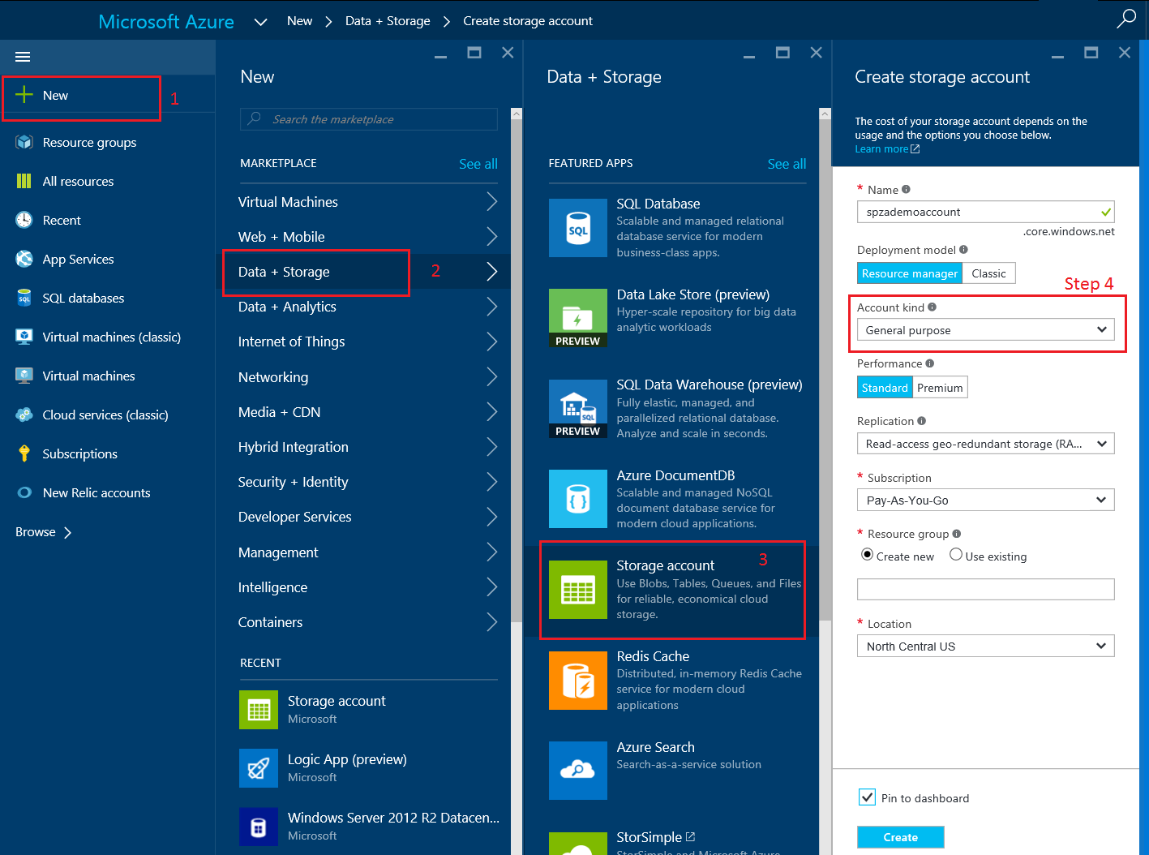  
   
Save the name of the storage account, this will be used to build the connection string later.   
  
3. You will see the Azure storage that you just created in your Azure dashboard. ([https://portal.azure.com](https://portal.azure.com/)).   
  
4. Get the storage account key and save it for creating the connection string. Use instructions below:   
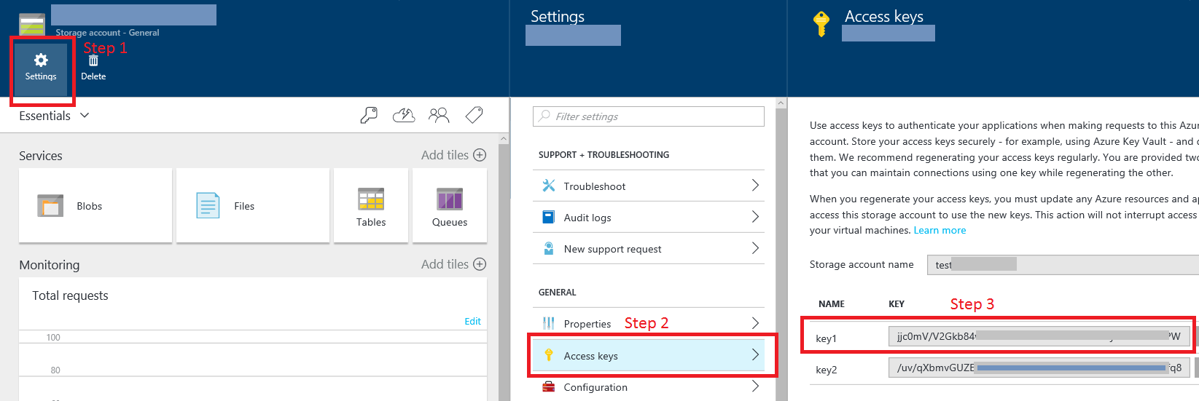  
   
  
5. Create connection string as below:   
{"connectionString":"DefaultEndpointsProtocol=https;AccountName=Value from step 2;AccountKey=Value from step 4;"}

Sample final connection string:   
{"connectionString":"DefaultEndpointsProtocol=https;AccountName=spzademoaccount;AccountKey=Ld4mIh4DVrsFEaSw21HKbqn05bl5hLVKcw0fJ4DIsa6RuvwlSMZJzQZM312IHersOIMof4DEouEmc0jw=="}

Please ensure that you don’t put any spaces before or after the values that you paste to create the connection string.   
  
6. You will see a test lead created in your storage table just after your app is successfully pushed to staging.   
  
7. You can use [Azure storage explorer](http://azurestorageexplorer.codeplex.com/) (third party app) or any other tool to see the data in your storage table or export the data.

# Appendix B – Marketing Metadata Guidelines

**Metadata Required**

Here is a list of the marketing metadata you will need to publish to AppSource. Below the table are some guidelines for this data.

|  |  |  |  |  |  |
| --- | --- | --- | --- | --- | --- |
| **Field** | **Type** | **Required** | **Displayed** | **Requirements** | **Where it’s defined in Publishing** |
| Company Name | String | Y | Y | Length – up to 30 characters | publishers→DEV CENTER ACCOUNT→Company Profile→SHORT NAME |
| Title | String | Y | Y | Length – up to 50 characters | crm package→<your offer name>→MARKETING→English (US)→DETAILS→Description→TITLE |
| Summary | String | Y | Y | Length – up to 100 characters | crm package→<your offer name>→MARKETING→English (US)→DETAILS→Description→SUMMARY |
| Description | Formatted HTML | Y | Y | Length – up to 4000 characters | crm package→<your offer name>→MARKETING→English (US)→DETAILS→Description→DESCRIPTION (HTML) |
| Industries | Array | N | N | Up to 2 | crm package→<your offer name>→CRM PACKAGE→Marketplace Listing Details→INDUSTRIES |
| Categories | Array | Y | Y | Up to 2 | crm package→<your offer name>→CRM PACKAGE→Marketplace Listing Details→CATEGORIES |
| Help Link | String URL to a help link for your app | Y | Y |  | crm package→<your offer name>→CRM PACKAGE→Marketplace Listing Details→PLEASE ENTER THE HELP LINK TO YOUR APP |
| Hide Key | Any short string | Y | N |  | crm package→<your offer name>→CRM PACKAGE→Marketplace Listing Details→ HIDE KEY TO TEST YOUR OFFER IN STAGING |
| Demo Videos | Youtube or Vimeo video links. Need to provide a name, URL to the video, and a thumbnail image. | N | Y | Up to 4 videos for each app. Thumbnail must be 1280px*720px | crm package→<your offer name>→CRM PACKAGE→Demo videos of your app |
| Documents | Document Name and files to be uploaded | Y | Y | At least 1 document and up to 3 | crm package→<your offer name>→CRM PACKAGE→Documents related to your app |
| Small offer logo | Image file | Y | Y | 48px*48px | crm package→<your offer name>→CRM PACKAGE→Logos and images for your app |
| Large offer logo | Image file | Y | Y | 216px*216px | crm package→<your offer name>→CRM PACKAGE→Logos and images for your app |
| App screenshots | Image files | Y | Y | At least 1 and up to 4, all must be 1280px*720px | crm package→<your offer name>→CRM PACKAGE→Logos and images for your app |

**General Guidance**

* Images should fit to the exact resolution we recommend, 1280x720
* Do not stretch or resize images/screenshots as that causes blurry images.
* Video thumbnails should use a 1280x720 screen and should NOT include the video player’s shell itself (So have a screen of the video, not a screen of YouTube player). If you are using YouTube, they generate thumbnails for you, and have several variations you can choose from, such as: [https://img.youtube.com/vi/<VIDEO_ID>/maxresdefault.jpg](https://img.youtube.com/vi/%3cVIDEO_ID%3e/maxresdefault.jpg). Note this image may be a poor image. In this case provide your own
* Do not include the play button in video thumbnails, that’s by AppSource so it’ll be standardized.

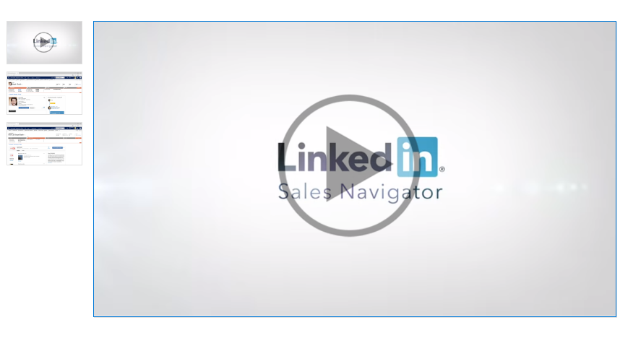

* Do not use drop shadows on screenshots. For images that intend to show menus etc. that are smaller than full screen, try to use a full-screen screenshot. We want to avoid all partial screenshots. You can use various methods to highlight the area if really need be including circling or other special effects
* If there’s absolutely no way to use a full screen due to part being a dialog, then show the dialog on top of a standard CRM screen as backdrop so that it is full screen
* To capture an exactly 1280x720 IMG we recommend either capture full size and using PS or some similar tool, or use Chrome’s size restriction in developer tools, or a plugin.

Chrome’s tool: Press F12

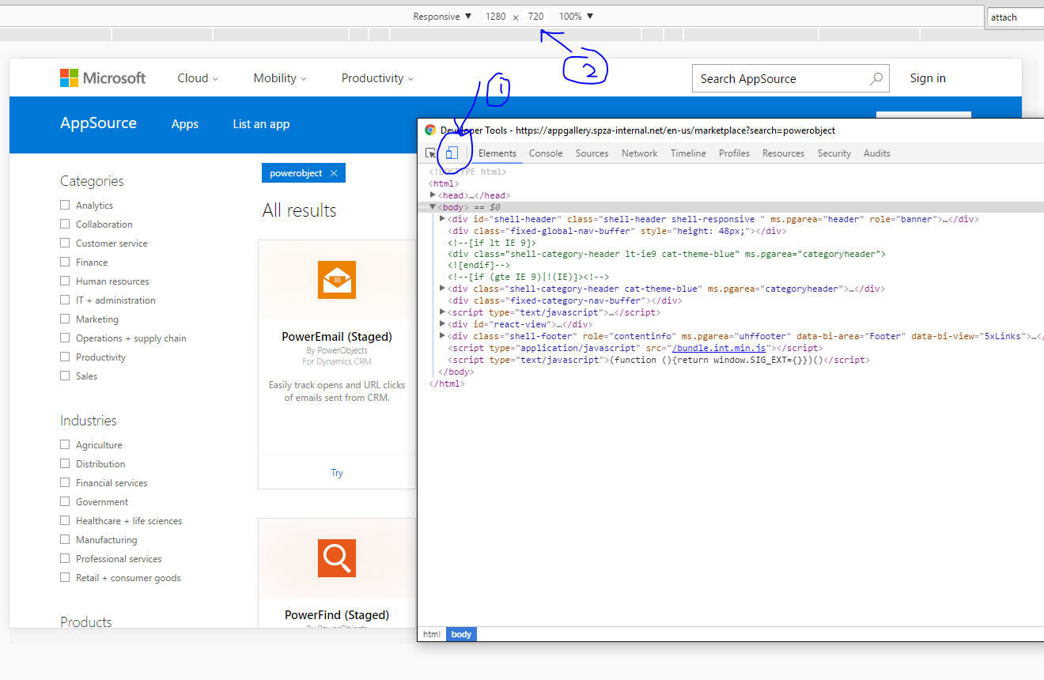

**Example for smaller images**

* We put this together using PowerPoint:

Original image (currently smaller images are either stretched or just smaller w/ backdrop

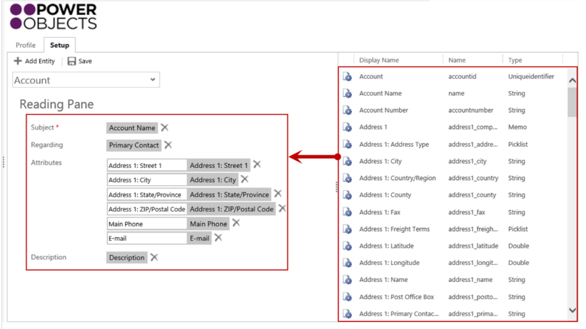

Modified image

